Hardware Requirements

# One Computer (For Capturing Packets From Self)

# Three Computers (For Capturing Packets Between Two Communicating Terminals)

# LAN Cards (Minimum one per terminal)

# Hub / Switch

# Patch Cords (According to the number of connections required)

Software Requiremnets

# Microsoft Windows (98/2000/XP/Vista), Linux (Fedora, Mandriva, Ubuntu), Mac OS X (Darwin), FreeBSD, and Solaris.

# Java Development Kit (JDK)

# Winpcap/Libpcap libraries for running in Windows/Linux respectively.

# Jpcap (Java Wrapper to Winpcap).

Open Systems Interconnect Model

Introduction
OSI is a standard description or "reference model" for how messages should be transmitted between any two points in a telecommunication network. Its purpose is to guide product implementors so that their products will consistently work with other products.
The Model
The OSI model was created by the IEEE committee so different vendors products would work with each other. You see the problem was that when HP decided to create a network product, it would be incompatible with similar products of a different vendor e.g. IBM. So when you bought 40 network cards for your company, you would make sure that the rest of the equipment would be from the same vendor, to ensure compatibility. As you would understand things were quite messy, until the OSI model came into the picture.
As most would know, the OSI model consists of 7 layers.
Each layer has been designed to do a specific task. Starting from the top layer (7) we will see how the data which you type gets converted into segments, the segments into datagrams and the datagrams into packets, the packets into frames and then the frames are sent down the wire, usually twisted pair, to the receiving computer.

The picture below is another quick summary of the OSI model:
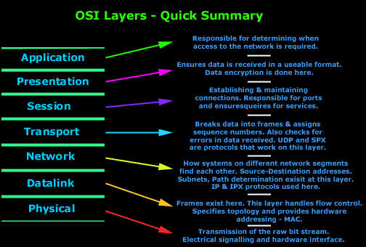
The first four layers define how data is transmitted end-to-end.
There are no protocols which work at the Physical layer. As mentioned, Ethernet, Token Ring and other topologies are specified here.

OSI Layer 1 - Physical Layer

The Physical layer has two responsibilities: it sends bits and receives bits. Bits come only in values of 1 or 0. The Physical layer communicates directly with the various types of actual communication media. Different kinds of media represent these bit values in different ways. Specific protocols are needed for each type of media to describe the proper bit patterns to be used, how data is encoded into media signals and the various qualities of the physical media's attachment interface.
The Physical layer specifications specify the electrical, mechanical and functional requirements for activating, maintaining and deactivating a physical link between end systems. At the physical layer, the interface between the Data Terminal Equipment (DTE) and the Data Circuit-Terminating Equipment (DCE) is identified. The Physical layer's connectors (RJ-45, BNC e.c.t) and different physical topologies (Bus, Star, Hybrid networks) are defined by the OSI as standards, allowing different systems to communicate.

OSI Layer 2 - Datalink Layer

The first four layers define how data is transmitted end-to-end.
Some common protocols which work at the Datalink layer are: ARP, RARP, DCAP.
The Datalink ensures that messages are delivered to the proper device and translates messages from the Network layer into bits for the Physical layer to transmit. It formats the message into data frames (notice how we are not using the term segments) and adds a customized header containing the hardware destination and source address.
This added information forms a sort of capsule that surrounds the original message (or data), think of it like grabbing a letter which has information and putting it into an envelope. The envelope is only used to get the letter to its destination, right? So when it arrives at the addressee, the envelope is opened and discarded, but the letter isn't because it has the information the addressee needs.
Data traveling through a network works in a similair manner. Once it gets to the destination, it will be opened and read (processed).
The Datalink layer is subdivided into two other sublayers, the Media Access Control (MAC) and the Logical Link Control (LLC). The figure below illustrates this:
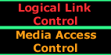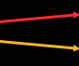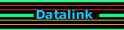
Media Access Control (MAC) 802.3
This defines how packets are placed on the media (cable). Contention media (Ethernet) access is first come first served access where everyone shares the same bandwidth. Physical addressing is defined here. What's Physical addressing? It's simple.
You will come across 2 addressing terms, 1)Logical addressing 2)Physical addressing.
Logical addressing is basically the address which is given by software e.g. IP address.When you get an IP address, this is considered a "logical address" which is provided to you after your TCP/IP stack is loaded.
Physical addressing is an address which is given not by the software, but the hardware. Every network card has a "MAC" address which is burnt into the card's eprom (a special memory chip) and this special address is used to uniquely identify your computer's network card from all the others on the network.
Logical Link Control (LLC) 802.2
This sublayer is responsible for identifying Network layer protocols and then encapsulating them when they are about to be transmitted onto the network or decapsulate them when it receives a packet from the network and pass it onto the layer above it, which is the Network layer. An LLC header tells the Datalink layer what to do with a packet once a frame is received. For example, a host (computer) will receive a frame and then look in the LLC header to understand that the packet is destined for the IP protocol at the Network layer. The LLC can also provide flow control and sequencing of control bits.

OSI Layer 3 - Network Layer
The first four layers define how data is transmitted end-to-end.
Some common protocols which work at the Network layer are: IP, DHCP, ICMP, IGRP, EIGRP, RIP, RIP2, MARS.
The Network layer is responsible for routing through an internetwork and for networking addressing. This means that the Network layer is responsible for transporting traffic between devices that are not locally attached. Routers, or other layer-3 devices, are specified at the Network layer and provide routing services in an internetwork.
In the Open Systems Interconnection (OSI) communications model, the Network layer knows the address of the neighboring nodes in the network, packages output with the correct network address information, selects routes and quality of service and recognizes and forwards to the Transport layer incoming messages for local host domains. Among existing protocol that generally map to the OSI network layer are the Internet Protocol (IP) part of TCP/IP and NetWare IPX/SPX. Both IP Version 4 and IP Version 6 (IPv6) map to the OSI network layer.
As mentioned above, the Internet Protocol works on this layer. This means that when you see an IP address, for example 192.168.0.1, this IP address maps to the Network layer in the OSI model, in other words only the Network layer deals with or cares about IP addresses in the OSI model. To keep things simple, IP is analyzed under the "Protocols" section.

OSI Layer 4 - Transport Layer
The first four layers define how data is transmitted end-to-end.
Some common protocols which work at the Transport layer are: TCP, UDP.
The Transport layer is responsible for providing mechanisms for multiplexing upper-layer application, session establishment, data transfer and tear down of virtual circuits. It also hides details of any network-dependent information from the higher layers by providing transparent data transfer.
Services located in the Transport layer both segment and reassemble data from upper-layer applications and unite it onto the same data stream. Some of you might already be familiar with TCP and UDP and know that TCP is a reliable service and UDP is not. Application developers have their choice of the two protocols when working with TCP/IP protocols.
As mentioned above, the Transport layer provides different mechanisms for the transfer of data from one computer to another. Below is a brief diagram which tells you a bit about the protocols.
These protocols are also analyzed in the Protocols area.
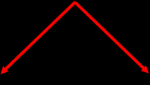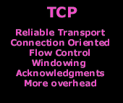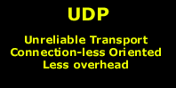

OSI Layer 5 - Session Layer

The last 3 layers of the OSI model are reffered to the "Upper" layers. These layers are responsible for applications communicating between hosts. None of the upper layers know anything about networking or network addresses.
Some common protocols which work at the Session layer are: DNS, LDAP, NetBIOS.
Layer 5 - The Session Layer
The Session layer is responsible for setting up, managing and then tearing down sessions between Presentation layer entities. The Session layer also provides dialog control between devices, or nodes. It coordinates communication between systems and serves to organise their communication by offering three different modes: simplex, half-duplex and full-duplex. The session layer basically keeps one application's data separate from other application's data.
Some examples of Session-layer protocols are:
Network File Systrem (NFS) : Was developed by Sun Microsystems and used with TCP/IP and Unix workstations to allow transparent access to remote resources.
Structured Query Language (SQL): Was developed by IBM to provide users with a simpler way to define their information requirements on both local and remote systems.
Remote Procedure Call (RPC): Is a broad client/server redirection tool used for disparate service environments. Its procedures are created on clients and performed on servers.
X Window: Is widely used by intelligent terminals for communicating with remote Unix computers, allowing them to operate as though they were locally attached monitors.

OSI Layer 6 - Presentation Layer
The last 3 layers of the OSI model are reffered to the "Upper" layers. These layers are responsible for applications communicating between hosts. None of the upper layers know anything about networking or network addresses.
There are no protocols which work specificly at the Presentation layer, but the protocols which work at the Application layer are said to work on all 3 upper layers.
The Presentation Layer gets its name from its purpose: It presents data to the Application layer. It's basically a translator and provides coding and conversion functions. A successful data transfer technique is to adapt the data into a standard format before transmission. Computers are configured to receive this generically formatted data and then convert the data back into its native format for reading. By providing translation services, the Presentation layer ensures that data transferred from the Application layer of one system can be read by the Application layer of another host.
The OSI has protocol standards that define how standard data should be formatted. Tasks like data compression, decompression, encryption and decryption are associated with this layer. Some Presentation layer standards are involved in multimedia operations. The following serve to direct graphic and visual image presentation :
JPEG: The Joint Photographic Experts Group brings these photo standards to us.
MIDI: The Musical Intrument Digital Interface is used for digitized music.
MPEG: The Moving Pictures Experts Group's standard for the compression and coding of motion video for CD's is very popular.
QuickTime: This is for use with Machintosh or Power PC programs, it manages audio and video applications.

OSI Layer 7 - Application Layer

The last 3 layers of the OSI model are reffered to the "Upper" layers. These layers are responsible for applications communicating between hosts. None of the upper layers know anything about networking or network addresses.
FTP, TFTP, Telnet, SMTP and other protocols work on the first three layers of the OSI model, which obviously includes the Application layer.
The Application layer of the OSI model is where users communicate with the computer. The Application layer is responsible for identifying and establishing the availability of the intended communication partner and determining if sufficient resources for the intended communication exist. The user interfaces with the computer at the application layer.
Although computer applications sometimes require only desktop resources, applications may unite communicating components from more than one network application, for example, file transfers, e-mail, remote access, network management activities, client/server processes.
There are various protocols which are used at this layer. Definition of a"Protocol" is a set of rules by which two computers communicate. In plain English, you can say that a protocol is a language, for example, English. For me to speak to you and make sense, I need to structure my sentence in a "standard" way which you will understand. Computer communication works pretty much the same way. This is why we have so many different protocols, each one for a specific task.

Introduction To Protocols

Introduction
In the networking and communications area, a protocol is the formal specification that defines the procedures that must be followed when transmitting or receiving data. Protocols define the format, timing, sequence, and error checking used on the network.
In plain english, the above means that if you have 2 or more devices e.g. computers which want to communicate, then they need a common "Protocol" which is a set of rules that guide the computers on how and when to talk to each other.
The way this "defenition" happens in computer land is by the RFC's (Requests For Comments) where the IETF (a group of enginners with no life) make up the new standards and protocols and then the major vendors (IBM, Cisco, Microsoft, Novell) follow these standards and implement them in their products to make more money and try to take over this world !
There are hundreads of protocols out there and it is impossible to list them all here, but instead we have included some of the most popular protocols around so you can read up on them and learn more about them.
The table below shows the most popular TCP/IP protocols. The OSI model is there for you to see which layer each of these protocols work at.
TCP/IP Protocol Stack ..................The OSI Model
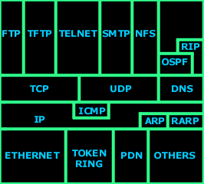 | 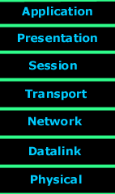 | Currently available protocols to read about are:  - Internet Protocol (IP)  - TCP  - UDP  - ICMP  - DNS  - FTP  - TFTP  - Ethernet  - RIP  - OSPF

Transmission Control Protocol

Introduction
The Transmission Control Protocol, or TCP as we will refer to it from now on, is one of the most important and well-known protocols in the world on networks today. Used in every type of network world-wide, it enables millions of data transmissions to reach their destination and works as a bridge, connecting hosts with one another and allowing them to use various programs in order to exchange data.
The Need For Reliable Delivery
TCP is defined by RFC 793 and was introduced to the world towards the end of 1981. The motivation behind creating such a protocol was the fact that back in the early 80s, computer communication systems were playing a very important role for the military, education and normal office environments. As such, there was the need to create a mechanism that would be robust, reliable and complete data transmission on various mediums without great losses.
TCP was designed to be able to deliver all of the above, and so it was adopted promptly by the rest of the world.

TCP, A Transport Protocol

Introduction
Understanding how each protocol fits into the OSI Model is essential for any network engineer. This page analyses how TCP is classified as a 'transport protocol' and gives you an insight into what to expect from the protocol.
Fitting TCP into the OSI Model
As most of you are well aware, every protocol has its place within the OSI Model. The OSI Model is an indication of the complexity and intelligence of the protocol. As a general rule, the higher you move up the OSI Model, the more intelligent protocols become. The positioning of the layer also reflects how CPU intensive they are, whereas the lower layers of the OSI Model are quite the opposite, that is, less CPU intensive and less intelligent.
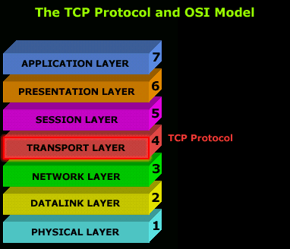 | TCP is placed at the 4th layer of the OSI Model, which is also known as the transport layer. If you have read through the OSI model pages, you will recall that the transport layer is responsible for establishing sessions, data transfer and tearing down virtual connections.  With this in mind, you would expect any protocol that's placed in the transport layer to implement certain features and characteristics that would allow it to support the functionality the layer provides.  So as we analyze TCP, you will surely agree that it fits right into the transport layer.

The diagram below shows you where the TCP header is located within a frame that's been generated by a computer and sent to the network. If you rotate it 90 degrees to your left, you would get something similar to the previous diagram. This of course is because each layer appends its own information, or header if you like:
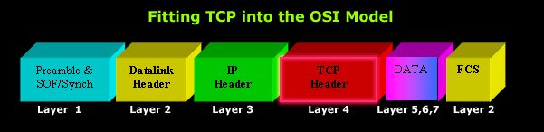
The frame is made up of six 3d blocks so you can see which piece is added by every OSI layer. You can see that the TCP Header containing all the options the protocol supports, is placed right after the IP Header (Layer 3), and before the data section that contains upper layer information (Layers 5,6,7).
.
The concept of a transport protocol
As we mentioned, TCP is a transport protocol and this means it is used to transfer data of other protocols. At first, this might sound weird or confusing but this is exactly why it was designed, adding substantial functionality to the protocols it carries.
The diagram below is the simplest way to show the concept of a 'transport' protocol:
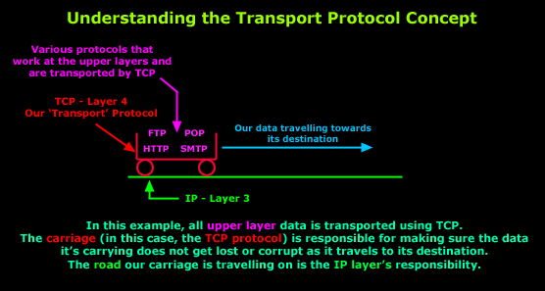
In the pages to follow, we will have a closer look at how TCP manages to provide its reliable data transfer method and make sure packets get to their destination without errors. This whole process is the work of many 'subsystems' within the TCP that work together to provide the reliability that TCP gives us.
Before we dive in deeper though, let's have a quick overall view of the protocol. If you're not interested in too much technical detail, then the next page is for you! For those looking for an in-depth analysis, you should read the quick-overview page to give you an idea on what we will be analyzing soon.

Quick Overview Of TCP

Introduction
To assist in making this process as painless and understandable as possible, we are going to provide a quick overview of the protocol and then start analyzing each component-field in the pages to come, using examples and the cool 3D diagrams you all love:)
As previously mentioned on a number of occasions, TCP is one of the two protocols that lives at the Transport layer and is used to carry data from one host to another. What makes TCP so popular is the way it works when sending and receiving data. Unlike UDP, TCP will check for errors in every packet it receives in an endless struggle to avoid data corruption.
Some common protocols that use TCP are: FTP, Telnet, HTTP, HTTPS, DNS, SMTP and POP3. Let's have a closer look at the main characteristics of this wonderful protocol.
When people refer to "TCP/IP" remember that they are talking about a suite of protocols and not just one protocol, like most people think. TCP/IP is not one protocol. Please see the Protocols section for more information.
Main Features
Here are the main features of the TCP that we are going to analyze:
- Reliable Transport
- Connection-Oriented
- Flow Control
- Windowing
- Acknowledgements
- More overhead
Reliable Transport
It's a reliable transport because of the different techniques it uses to ensure that the data received is error free. TCP is a robust protocol used for file transfers where data error is not an option. When you decide to download a 50MB file from a website, you wouldn't want to find out after the download is complete that the file has an error! Even though, in reality, this does happen, it just goes to show that you can't always be perfect with certain things.
This picture shows the TCP header within an Ethernet II frame. Right below this you will find our second diagram that zooms into to the TCP header, displaying the field the protocol contains:
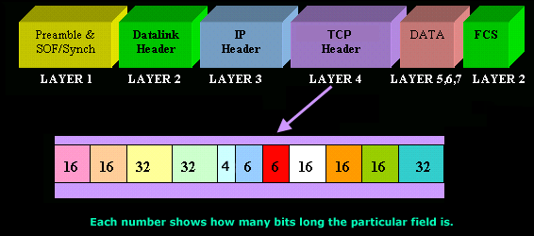

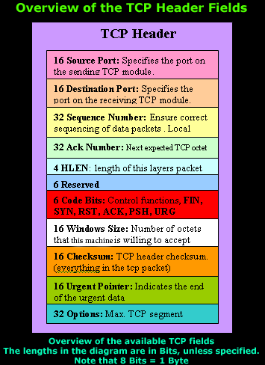 | The diagram on the left shows the individual breakdown of each field within the TCP header along with its length in bits.  Remember that 8 bits equal to 1 byte.  The most popular fields within the TCP header are the Source Port, Destination Port and Code bits. These Code bits are also known as 'flags'.  The rest of the fields help make sure all TCP segments make it to their destination and are reassembled in the correct order, while at the same time providing an error free mechanism should a few segments go missing and never reach their destination.  Keep in mind that in the pages to follow we will have a detailed look into each available field, for now we are just providing an overview of them.

Connection Oriented
What this basically means is that a connection is established between the two hosts or rather, the two computers, before any data is transferred. When the term "connection is established" is used, this means that both computers know about each other and have agreed on the exchange of data. This is also where the famous 3-way handshake happens. You will find the SYN and ACK bits in the Code bits field which are used to perform the 3-way handshake. Thanks to the 3-way handshake, TCP is connection oriented.
The following diagram explains the procedure of the 3-way handshake:
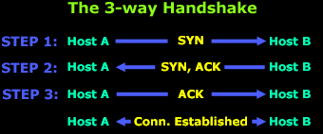
STEP 1: Host A sends the initial packet to Host B. This packet has the "SYN" bit enabled. Host B receives the packet and sees the "SYN" bit which has a value of "1" (in binary, this means ON) so it knows that Host A is trying to establish a connection with it.
STEP 2: Assuming Host B has enough resources, it sends a packet back to Host A and with the "SYN and ACK" bits enabled (1). The SYN that Host B sends, at this step, means 'I want to synchronize with you' and the ACK means 'I acknowledge your previous SYN request'.
STEP 3: So... after all that, Host A sends another packet to Host B and with the "ACK" bit set (1), it effectively tells Host B 'Yes, I acknowledge your previous request'.
Once the 3-way handshake is complete, the connection is established (virtual circuit) and the data transfer begins.
Flow Control
Flow control is used to control the data flow between the connection. If for any reason one of the two hosts are unable to keep up with the data transfer, it is able to send special signals to the other end, asking it to either stop or slow down so it can keep up.
For example, if Host B was a webserver from which people could download games, then obviously Host A is not going to be the only computer downloading from this webserver, so Host B must regulate the data flow to every computer downloading from it. This means it might turn to Host A and tell it to wait for a while until more resources are available because it has another 20 users trying to download at the same time.
Below is a diagram that illustrates a simple flow control session between two hosts.
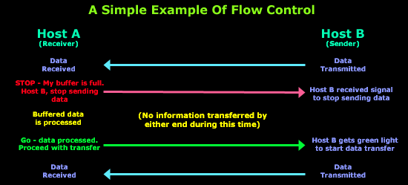
Generally speaking, when a machine receives a flood of data too quickly for it to process, it stores it in a memory section called a buffer. This buffering action solves the problem only if the data bursts are small and don't last long.
However, if the data burst continues it will eventually exhaust the memory of the receiving end and that will result in the arriving data being discarded. So in this situation the receiving end will simply issue a "Not ready" or "Stop" indicator to the sender, or source of the flood. After the receiver processes the data it has in its memory, it sends out a "Ready" or "Go" transport indicator and the sending machine receives the "Go" indicator and resumes its transmission.
Windowing
Data throughput, or transfer efficiency, would be low if the transmitting machine had to wait for an acknowledgment after sending each packet of data (the correct term is segment as we will see on the next page). Because there is time available after the sender transmits the data segment and before it finishes processing acknowledgments from the receiving machine, the sender uses the break to transmit more data. If we wanted to briefly define Windowing we could do so by stating that it is the number of data segments the transmitting machine is allowed to send without receiving an acknowledgment for them.
Windowing controls how much information is transferred from one end to the other. While some protocols quantify information by observing the number of packets, TCP/IP measures it by counting the number of bytes.
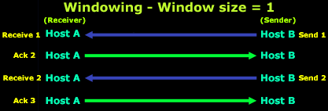
Let's explain what is happening in the above diagram.
Host B is sending data to Host A, using a window size equal to one. This means that Host B is expecting an "ACK" for each data segment it sends to Host A. Once the first data segment is sent, Host A receives it and sends an "ACK 2" to Host B. You might be wondering why "ACK 2" and not just "ACK"?
The "ACK 2" is translated by Host B to say: 'I acknowledge (ACK) the packet you just sent me and I am ready to receive the second (2) segment'. So Host B gets the second data segment ready and sends it off to Host A, expecting an "ACK 3" response from Host A so it can send the third data segment for which, as the picture shows, it receives the "ACK 3".
However, if it received an "ACK 2" again, this would mean something went wrong with the previous transmission and Host B will retransmit the lost segment. We will see how this works in the Acknowledgments section later on. Let's now try a different Window size to get a better understanding.. let's say 3!
Keep in mind the way the "ACK's" work, otherwise you might find the following example a bit confusing. If you can't understand it, read the previous example again where the Window size was equal to one.
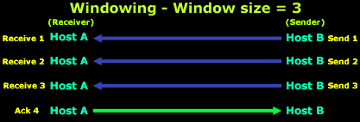
In the above example, we have a window size equal to 3, which means that Host B can send 3 data segments to Host A before expecting an "ACK" back. Host B sends the first 3 segments (Send 1, Send 2 and Send 3), Host A receives them all in good condition and then sends the "ACK 4" to Host B. This means that Host A acknowledged the 3 data segments Host B sent and awaits the next data segments which, in this case, would be 4, 5 and 6.
Acknowledgments
Reliable data delivery ensures the integrity of a stream of data sent from one machine to the other through a fully functional data link. This guarantees the data won't be duplicated or lost. The method that achieves this is known as positive acknowledgment with retransmission. This technique requires a receiving machine to communicate with the transmitting source by sending an acknowledgment message back to the sender when it receives data. The sender documents each segment it sends and waits for this acknowledgment before sending the next segment. When it sends a segment, the transmitting machine starts a timer and retransmits if it expires before an acknowledgment is returned from the receiving end.
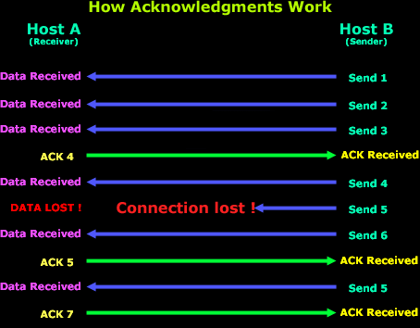
This figure shows how the Acknowledgments work. If you examine the diagram closely you will see the window size of this transfer which is equal to 3. At first, Host B sends 3 data segments to Host A and they are received in perfect condition so, based on what we learned, Host A sends an "ACK 4" acknowledging the 3 data segments and requesting the next 3 data segments which will be 4, 5, 6. As a result, Host B sends data segments 4, 5, 6 but 5 gets lost somewhere along the way and Host A doesn't receive it so, after a bit of waiting, it realizes that 5 got lost and sends an "ACK 5" to Host B, indicating that it would like data segment 5 retransmitted. Now you see why this method is called "positive acknowledgment with retransmission".
At this point Host B sends data segment 5 and waits for Host A to send an "ACK" so it can continue sending the rest of the data. Host A receives the 5th data segment and sends "ACK 7" which means 'I received the previous data segment, now please send me the next 3'. The next step is not shown on the diagram but it would be Host B sending data segments 7, 8 and 9.
More Overhead
As you can see, there is quite a neat mechanism under the TCP hood that enables data to be transferred error free. All the features the protocol supports come at a price, and this is the overhead associated with TCP.
When we talk about overhead, we are referring to all the different fields contained within the TCP header and error checking that takes place to ensure no portion of the data is corrupt. While for most this is a fair trade off, some people simply can't spare the extra processing power, bandwidth and increased time the TCP transactions require, for this reason we have the alternative UDP protocol, which you can read about in the UDP protocol section.
At this point our quick overview of the TCP has reached its conclusion. From the next page onwards, we start to dive in deeper, so take a deep breath and jump right into it!

The TCP Header/Segment

Introduction
This page will introduce several new concepts, nothing of great difficulty, but essential for you to understand. We will learn what a TCP segment is, analyze it and start to explore the guts of TCP :)
So buckle up and get ready. It's all really simple, you just need to clear your mind and try to see things in the simplest form and you will discover how easy and friendly TCP really is. You can only feel comfortable with something once you get to know it.
TCP Header and TCP Segment
If we wanted to be more accurate with the terms we use, then perhaps we would title this page as "Analyzing A TCP Segment". Why? Well, that's what it's called in the networking world so we need to know it by the correct term.
This of course leads us to another new definition, a TCP segment:
The unit of transfer between the TCP software on to machines is called a TCP segment.
If your expression has transformed itself to resemble a confused person, then don't worry, just keep reading...
Understanding this term is easier than you thought 5 seconds ago, just take a good look at the diagram below:
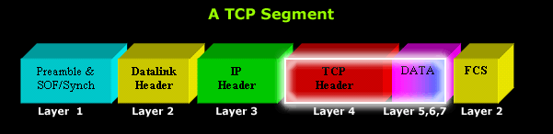
Now you see that a TCP segment is basically the TCP header plus the data that's right behind it and, of course, the data belongs to the upper layers (5,6,7).
The data contents could be part of a file transfer, or the response from a http request, the fact is that we really are not interested in the data's contents, but only in the fact that it's part of the TCP segment.
The screen shot below was taken from my packet sniffer, and it shows the DATA portion belonging to the TCP Header:

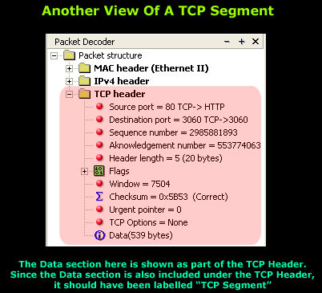

Getting Ready To Analyse The TCP Header
The last screen shot certainly gives out a fair bit of information, but there is still much that hasn't been revealed, not to mention nothing's really been analyzed as yet :)

Analyzing The TCP Header

Introduction
A fair amount of time was spent trying to figure out which way to analyze the TCP header. Most websites and other resources mention the protocol's main characteristics with a bit of information attached, leaving the reader with a lot of questions and making it difficult to comprehend how certain aspects of the protocol works.
For this reason a different approach was selected. Our method certainly gets right into the protocol's guts and contains a lot of information which some of you might choose to skip, but it is guaranteed to satisfy you by giving a thorough understanding of what is going on.
The diagram below shows the TCP header captured from a packet that I was running on the network. We'll be using it to help us through our step by step analysis of TCP.
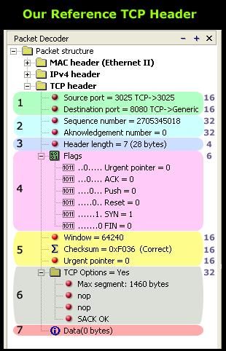 | As you can see, the TCP header has been completely expanded to show us all the fields the protocol contains. The numbers on the right are each field's length in bits. This is also shown in the quick TCP overview page.  Since much time was spent to ensure our analysis was complete in all aspects, be sure that by the end of it, you will understand each field's purpose and how it works.  We should also point out that when the packet in our example arrives to its destination, only section 7 (the last one) is sent to the upper OSI layers because it contains the data it is waiting for. The rest of the information (including the MAC header, IP Header and TCP header) is overhead which serves the purpose of getting the packet to its destination and allowing the receiving end to figure out what to do with the packet, e.g. send the data to the correct local application.  Now you're starting to understand the somewhat complex mechanism involved in determining how data gets from one point to another!
- Section 1: Source & Destination Port Number
- Section 2: Sequence & Acknowledgement Numbers
- Section 3: Header Length
- Section 4: TCP Flag Options
- Section 5: Window Size, Checksum & Urgent Pointer
- Section 6: TCP Options
- Section 7: Data

TCP Analysis - Section 1: Source & Destination port number

Introduction
This section contains one of the most well-known fields in the TCP header, the Source and Destination port numbers. These fields are used to specify the application or services offered on local or remote hosts.
You will come to understand how important ports are and how they can be used to gain information on remote systems that have been targeted for attacks. We will cover basic and advanced port communications using detailed examples and colorful diagrams, but for now, we will start with some basics to help break down the topic and allow us to smoothly progress in to more advanced and complex information.
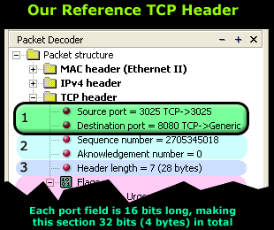 | When a host needs to generate a request or send data, it requires some information:  1) IP Address of the desired host to which it wants to send the data or request.  2) Port number to which the data or request should be sent to on the remote host. In the case of a request, it allows the sender to specify the service it is intending to use. We will analyze this soon.
1) The IP Address is used to uniquely identify the desired host we need to contact. This information is not shown in the above packet because it exists in the IP header section located right above the TCP header we are analyzing. If we were to expand the IP header, we would (certainly) find the source and destination IP Address fields in there.
2) The 2nd important aspect, the port number, allows us to identify the service or application our data or request must be sent to, as we have previously stated. When a host, whether it be a simple computer or a dedicated server, offers various services such as http, ftp, telnet, all clients connecting to it must use a port number to choose which particular service they would like to use.
The best way to understand the concept is through examples and there are plenty of them below, so let's take a look at a few, starting from a simple one and then moving towards something slightly more complicated.
Time To Dive Deeper!
Let's consider your web browser for a moment.
When you send a http request to download a webpage, it must be sent to the correct web server in order for it to receive it, process it and allow you to view the page you want. This is achieved by obtaining the correct IP address via DNS resolution and sending the request to the correct port number at the remote machine (web server). The port value, in the case of an http request, is usually 80.
Once your request arrives at the web server, it will check that the packet is indeed for itself. This is done by observing the destination IP Address of the newly received packet. Keep in mind that this particular step is a function of the Network layer.
Once it verifies that the packet is in fact for the local machine, it will process the packet and see that the destination port number is equal to 80. It then realizes it should send the data (or request) to the http deamon that's waiting in the background to serve clients:
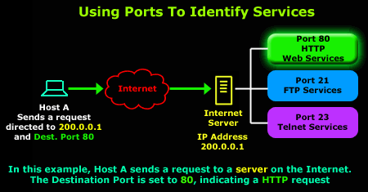
Using this neat method we are able to use the rest of the services offered by the server. So, to use the FTP service, our workstation generates a packet that is directed to the server's IP address, that is 200.0.0.1, but this time with a destination port of 21.
The diagram that follows illustrates this process:
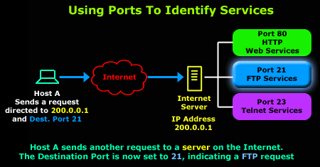
By now you should understand the purpose of the destination port and how it allows us to select the services we require from hosts that offer them.
For those who noticed, our captured packet at the beginning of this page also shows the existence of another port, the source port, which we are going to take a look at below.
Understanding the Source Port
The source port serves analogues to the destination port, but is used by the sending host to help keep track of new incoming connections and existing data streams.
As most of you are well aware, in TCP/UDP data communications, a host will always provide a destination and source port number. We have already analyzed the destination port, and how it allows the host to select the service it requires. The source port is provided to the remote machine, in the case of our example, this is the Internet Server, in order for it to reply to the correct session initiated by the other side.
This is achieved by reversing the destination and source ports. When the host (in our example, Host A) receives this packet, it will identify the packet as a reply to the previous packet it sent:
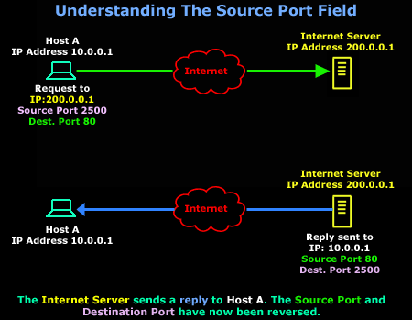
As Host A receives the Internet Server's reply, the Transport layer will notice the reversed ports and recognize it as a response to the previous packet it sent (the one with the green arrow).
The Transport and Session layers keep track of all new connections, established connections and connections that are in the process of being torn down, which explains how Host A remembers that it's expecting a reply from the Internet Server.
Of course the captured packet that's displayed at the beginning of the page shows different port numbers than the ones in these diagrams. In that particular case, the workstation sends a request to its local http proxy server that runs on port 8080, using port 3025 as its source port.
We should also note that TCP uses a few more mechanisms to accurately keep track of these connections. The pages to follow will analyze them as well, so don't worry about missing out on any information, just grab some brain food (hhmmm chocolate...), sit back, relax and continue reading!

TCP Analysis - Section 2: Sequence & Acknowledgement Numbers

Introduction
This page will closely examine the Sequence and Acknowledgement numbers. The very purpose of their existence is related directly to the fact that the Internet, and generally most networks, are packet switched (we will explain shortly) and because we nearly always send and receive data that is larger than the maximum transmission unit (a.k.a MTU - analyzed on sections 5 and 6 ) which is 1500 on most networks.
Let's take a look at the fields we are about to analyze:
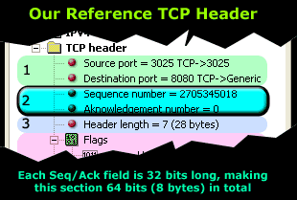 | As you can see, the Sequence number proceeds the Acknowledgement number.  We are going to explain how these numbers increment and what they mean, how various operating systems handle them in a different manner and lastly, what way these numbers can become a security hazard for those who require a solid secure network.
TCP - Connection Oriented Protocol
The Sequence and Acknowledgement fields are two of the many features that help us classify TCP as a connection oriented protocol. As such, when data is sent through a TCP connection, they help the remote hosts keep track of the connection and ensure that no packet has been lost on the way to its destination.
TCP utilizes positive acknowledgments, timeouts and retransmissions to ensure error-free, sequenced delivery of user data. If the retransmission timer expires before an acknowledgment is received, data is retransmitted starting at the byte after the last acknowledged byte in the stream.
A further point worth mentioning is the fact that Sequence numbers are generated differently on each operating system. Using special algorithms (and sometimes weak ones), an operating system will generate these numbers, which are used to track the packets sent or received, and since both Sequence and Acknowledgement fields are 32bit, there are 2^32= 4,294,967,296 possibilities of generating a different number!
Initial Sequence Number (ISN)
When two hosts need to transfer data using the TCP transport protocol, a new connection is created. This involves the first host that wishes to initiate the connection, to generate what is called an Initial Sequence Number (ISN), which is basically the first sequence number that's contained in the Sequence field we are looking at. The ISN has always been the subject of security issues, as it seems to be a favorite way for hackers to 'hijack' TCP connections.
Believe it or not, hijacking a new TCP connection is something an experienced hacker can alarmingly achieve with very few attempts. The root of this security problem starts with the way the ISN is generated.
Every operating system uses its own algorithm to generate an ISN for every new connection, so all a hacker needs to do is figure out, or rather predict, which algorithm is used by the specific operating system, generate the next predicted sequence number and place it inside a packet that is sent to the other end. If the attacker is successful, the receiving end is fooled and thinks the packet is a valid one coming from the host that initiated the connection.
At the same time, the attacker will launch a flood attack to the host that initiated the TCP connection, keeping it busy so it won't send any packets to the remote host with which it tried to initiate the connection.
Here is a brief illustration of the above-mentioned attack:
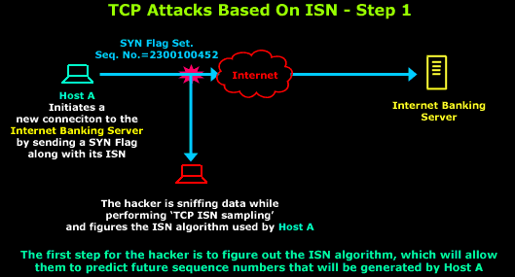
As described, the hacker must find the ISN algorithm by sampling the Initial Sequence Numbers used in all new connections by Host A. Once this is complete and the hacker knows the algorithm and they are ready to initiate their attack:
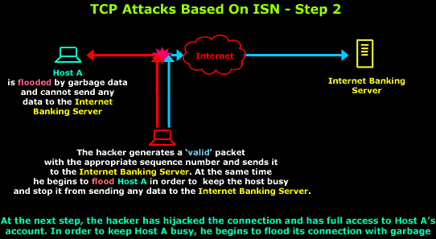
Timing is critical for the hacker, so he sends his first fake packet to the Internet Banking Server while at the same time starts flooding Host A with garbage data in order to consume the host's bandwidth and resources. By doing so, Host A is unable to cope with the data it's receiving and will not send any packets to the Internet Banking Server.
The fake packet sent to the Internet Banking Server will contain valid headers, meaning it will seem like it originated from Host A's IP Address and will be sent to the correct port the Internet Banking Server is listening to.
There have been numerous reports published online that talk about the method each operating system uses to generate its ISN and how easy or difficult it is to predict. Do not be alarmed to discover that the Windows operating system's ISN algorithm is by far the easiest to predict!
Programs such as 'Nmap' will actually test to see how difficult it can be to discover the ISN algorithm used in any operating system. In most cases, hackers will first sample TCP ISN's from the host victim, looking for patterns in the initial sequence numbers chosen by TCP implementations when responding to a connection request. Once a pattern is found it's only a matter of minutes for connections initiated by the host to be hijacked.
Example of Sequence and Acknowledgment Numbers
To help us understand how these newly introduced fields are used to track a connection's packets, an example is given below.
Before we proceed, we should note that you will come across the terms "ACK flag" or "SYN flag"; these terms should not be confused with the Sequence and Acknowledgment numbers as they are different fields within the TCP header. The screen shot below is to help you understand:

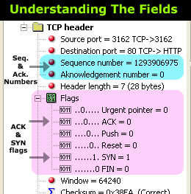 | You can see the Sequence number and Acknowledgement number fields, followed by the TCP Flags to which we're referring.  The TCP Flags (light purple section) will be covered on the pages to come in much greater depth, but because we need to work with them now to help us examine how the Sequence and Acknowledgement numbers work, we are forced to analyze a small portion of them.  To keep things simple, remember that when talking about Sequence and Acknowledgement numbers we are referring to the blue section, while SYN and ACK flags refer to the light purple section.

The next diagram shows the establishment of a new connection to a web server - the Gateway Server. The first three packets are part of the 3-way handshake performed by TCP before any data is transferred between the two hosts, while the small screen shot under the diagram is captured by our packet sniffer:
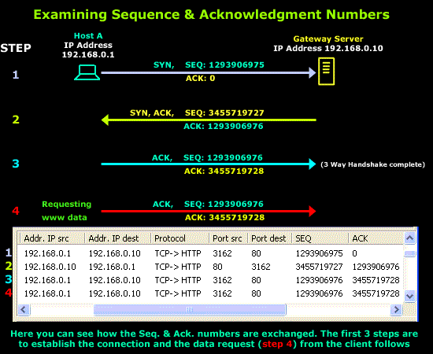
To make sure we understand what is happening here, we will analyze the example step by step.
Step 1
Host A wishes to download a webpage from the Gateway Server. This requires a new connection between the two to be established so Host A sends a packet to the Gateway Server. This packet has the SYN flag set and also contains the ISN generated by Host A's operating system, that is 1293906975. Since Host A is initiating the connection and hasn't received a reply from the Gateway Server, the Acknowledgment number is set to zero (0).
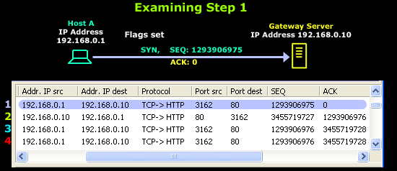
In short, Host A is telling the Gateway Server the following: "I'd like to initiate a new connection with you. My Sequence number is 1293906975".
Step 2
The Gateway Server receives Host A's request and generates a reply containing its own generated ISN, that is 3455719727, and the next Sequence number it is expecting from Host A which is 1293906976. The Server also has the SYN & ACK flags set, acknowledging the previous packet it received and informing Host A of its own Sequence number.
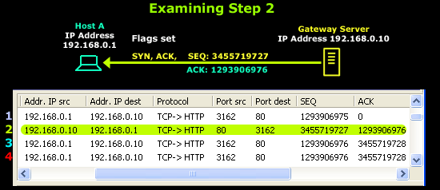
In short, the Gateway Server is telling Host A the following: "I acknowledge your sequence number and expecting your next packet with sequence number 1293906976. My sequence number is 3455719727".
Step 3
Host A receives the reply and now knows Gateway's sequence number. It generates another packet to complete the connection. This packet has the ACK flag set and also contains the sequence number that it expects the Gateway Server to use next, that is 3455719728.
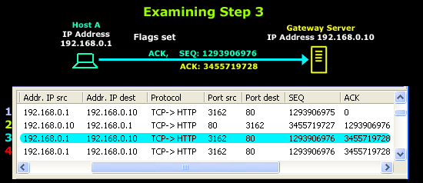
In short, Host A is telling the Gateway Server the following: "I acknowledge your last packet. This packet's sequence number is 1293906976, which is what you're expecting. I'll also be expecting the next packet you send me to have a sequence number of 3455719728".
Now, someone might be expecting the next packet to be sent from the Gateway Server, but this is not the case. You might recall that Host A initiated the connection because it wanted to download a web page from the Gateway Server. Since the 3-way TCP handshake has been completed, a virtual connection between the two now exists and the Gateway Server is ready to listen to Host A's request.
With this in mind, it's now time for Host A to ask for the webpage it wanted, which brings us to step number 4.
Step 4
In this step, Host A generates a packet with some data and sends it to the Gateway Server. The data tells the Gateway Server which webpage it would like sent.
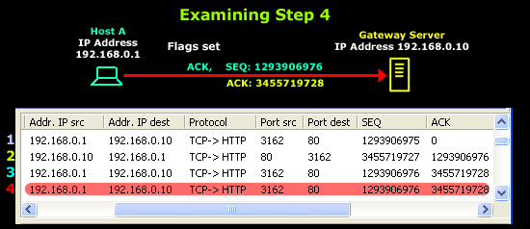
Note that the sequence number of the segment in line 4 is the same as in line 3 because the ACK does not occupy sequence number space.
So keep in mind that any packets generated, which are simply acknowledgments (in other words, have only the ACK flag set and contain no data) to previously received packets, never increment the sequence number.
Last Notes
There are other important roles that the Sequence and Acknowledgement numbers have during the communication of two hosts. Because segments (or packets) travel in IP datagrams, they can be lost or delivered out of order, so the receiver uses the sequence numbers to reorder the segments. The receiver collects the data from arriving segments and reconstructs an exact copy of the stream being sent.
If we have a closer look at the diagram above, we notice that the TCP Acknowledgement number specifies the sequence number of the next segment expected by the receiver. Simply scroll back to Step 2 and you will see what I mean.

TCP Analysis - Section 3: Header Length

Introduction
The third field under close examination is the TCP Header length. There really isn't that much to say about the Header length other than to explain what it represents and how to interpret its values, but this alone is very important as you will soon see.
Let's take a quick look at this field, noting its location within the TCP structure:
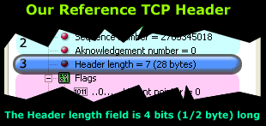 | You might also have seen the Header length represented as "Data offset" in other packet sniffers or applications, this is virtually the same as the Header length, only with a 'fancier' name.  Analyzing the Header length  If you open any networking book that covers the TCP header, you will almost certainly find the following description for this particular field:
"An integer that specifies the length of the segment header measured in 32-bit multiples" (Internetworking with TCP/IP, Douglas E. Comer, p. 204, 1995). This description sounds impressive, but when you look at the packet, you're most likely to scratch your head thinking: what exactly did that mean?
Well, you can cease being confused because we are going to cover it step by step, giving answers to all possible questions you might have. If we don't cover your questions completely, well... there are always our forums to turn to!
Step 1 - What portion is the "Header length" ?
Before we dive into analyzing the meaning of the values used in this field, which by the way changes with every packet, we need to understand which portion on the packet is the "Header length".
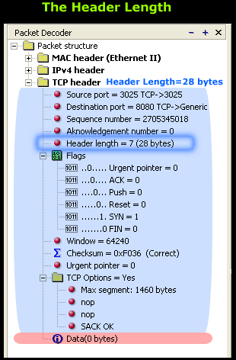 | Looking at the screen shot on the left, the light blue highlighted section shows us the section that's counted towards the Header length value. With this in mind, you can see that the total length of the light blue section (header length) is 28 bytes.  The Header length field is required because of the TCP Options field, which contains various options that might or might not be used. Logically, if no options are used then the header length will be much smaller.  If you take a look at our example, you will notice the 'TCP Options' is equal to 'yes', meaning there are options in this field that are used in this particular connection. We've expanded the section to show the TCP options used and these are 'Max Segment' and 'SACK OK'. These will be analyzed in the pages which follow, at the present time though we are interested in whether the TCP options are used or not.  As the packet in our screenshot reaches the receiving end, the receiver will read the header length field and know exactly where the data portion starts.
This data will be carried to the layers above, while the TCP header will be stripped and disregarded. In this example, we have no data, which is normal since the packet is initiating a 3-way handshake (Flags, SYN=1), but we will cover that in more depth on the next page.
The main issue requiring our attention deals with the values used for the header length field and learning how to interpret them correctly.

Step 2 - Header Value Analysis
From the screen shot above, we can see our packet sniffer indicating that the field has a value of 7(hex) and this is interpreted as 28 bytes. To calculate this, you take the value of 7, multiply it by 32 and divide the result by 8: 7x32=224/8=28 bytes.
Do you recall the definition given at the beginning of this page? "An integer that specifies the length of the segment header measured in 32-bit multiples". This was the formal way of describing these calculations :)
The calculation given is automatically performed by our packet sniffer, which is quite thoughtful, wouldn't you agree? This can be considered, if you like, as an additional 'feature' found on most serious packet sniffers.
Below you will find another screen shot from our packet sniffer that shows a portion of the TCP header (left frame) containing the header length field. On the right frame, the packet sniffer shows the packet's contents in hex:
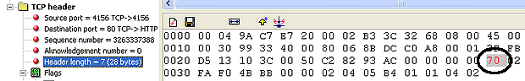
By selecting the Header length field on the left, the program automatically highlights the corresponding section and hex value on the right frame. According to the packet sniffer, the hex value '70' is the value for the header length field.
If you recall at the beginning of the page, we mentioned the header length field being 4 bits long. This means that when viewing the value in hex, we should only have one digit or character highlighted, but this isn't the case here because the packet sniffer has incorrectly highlighted the '7' and '0' together, giving us the impression that the field is 8 bits long!
Note: In hex, each character e.g. '7' represents 4 bits. This means that on the right frame, only '7' should be highlighted, and not "70". Furthermore, if we were to convert '7' hex to binary, the result would be '0111' (notice the total amount of bits is equal to 4).

TCP Analysis - Section 4: TCP Flag Options

Introduction
As we have seen in the previous pages, some TCP segments carry data while others are simple acknowledgements for previously received data. The popular 3-way handshake utilizes the SYNs and ACKs available in the TCP to help complete the connection before data is transferred.
Our conclusion is that each TCP segment has a purpose, and this is determined with the help of the TCP flag options, allowing the sender or receiver to specify which flags should be used so the segment is handled correctly by the other end.
Let's take a look at the TCP flags field to begin our analysis:
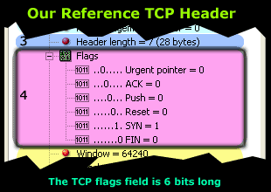 | You can see the 2 flags that are used during the 3-way handshake (SYN, ACK) and data transfers.  As with all flags, a value of '1' means that a particular flag is 'set' or, if you like, is 'on'. In this example, only the "SYN" flag is set, indicating that this is the first segment of a new TCP connection.  In addition to this, each flag is one bit long, and since there are 6 flags, this makes the Flags section 6 bits in total.
You would have to agree that the most popular flags are the "SYN", "ACK" and "FIN", used to establish connections, acknowledge successful segment transfers and, lastly, terminate connections. While the rest of the flags are not as well known, their role and purpose makes them, in some cases, equally important.
We will begin our analysis by examining all six flags, starting from the top, that is, the Urgent Pointer:
- Urgent Pointer
- ACKnowledgement
- PUSH
- Reset (RST) Flag
- FIN Flag
- SYNchronisation Flag
1st Flag - Urgent Pointer
The first flag is the Urgent Pointer flag, as shown in the previous screen shot. This flag is used to identify incoming data as 'urgent'. Such incoming segments do not have to wait until the previous segments are consumed by the receiving end but are sent directly and processed immediately.
An Urgent Pointer could be used during a stream of data transfer where a host is sending data to an application running on a remote machine. If a problem appears, the host machine needs to abort the data transfer and stop the data processing on the other end. Under normal circumstances, the abort signal will be sent and queued at the remote machine until all previously sent data is processed, however, in this case, we need the abort signal to be processed immediately.
By setting the abort signal's segment Urgent Pointer flag to '1', the remote machine will not wait till all queued data is processed and then execute the abort. Instead, it will give that specific segment priority, processing it immediately and stopping all further data processing.
If you're finding it hard to understand, consider this real-life example:
At your local post office, hundreds of trucks are unloading bags of letters from all over the world. Because the amount of trucks entering the post office building are abundant, they line up one behind the other, waiting for their turn to unload their bags.
As a result, the queue ends up being quite long. However, a truck with a big red flag suddenly joins the queue and the security officer, whose job it is to make sure no truck skips the queue, sees the red flag and knows it's carrying very important letters that need to get to their destination urgently. By following the normal procedures, the security officer signals to the truck to skip the queue and go all the way up to the front, giving it priority over the other the trucks.
In this example, the trucks represent the segments that arrive at their destination and are queued in the buffer waiting to be processed, while the truck with the red flag is the segment with the Urgent Pointer flag set.
A further point to note is the existence of the Urgent Pointer field. This field is covered in section 5, but we can briefly mention that when the Urgent Pointer flag is set to '1' (that's the one we are analyzing here), then the Urgent Pointer field specifies the position in the segment where urgent data ends.
2nd Flag - ACKnowledgement
The ACKnowledgement flag is used to acknowledge the successful receipt of packets.
If you run a packet sniffer while transferring data using the TCP, you will notice that, in most cases, for every packet you send or receive, an ACKnowledgement follows. So if you received a packet from a remote host, then your workstation will most probably send one back with the ACK field set to "1".
In some cases where the sender requires one ACKnowledgement for every 3 packets sent, the receiving end will send the ACK expected once (the 3rd sequential packet is received). This is also called Windowing and is covered extensively in the pages that follow.

3rd Flag - PUSH
The Push flag, like the Urgent flag, exists to ensure that the data is given the priority (that it deserves) and is processed at the sending or receiving end. This particular flag is used quite frequently at the beginning and end of a data transfer, affecting the way the data is handled at both ends.
When developers create new applications, they must make sure they follow specific guidelines given by the RFC's to ensure that their applications work properly and manage the flow of data in and out of the application layer of the OSI model flawlessly. When used, the Push bit makes sure the data segment is handled correctly and given the appropriate priority at both ends of a virtual connection.
When a host sends its data, it is temporarily queued in the TCP buffer, a special area in the memory, until the segment has reached a certain size and is then sent to the receiver. This design guarantees that the data transfer is as efficient as possible, without wasting time and bandwidth by creating multiple segments, but combining them into one or more larger ones.
When the segment arrives at the receiving end, it is placed in the TCP incoming buffer before it is passed onto the application layer. The data queued in the incoming buffer will remain there until the other segments arrive and, once this is complete, the data is passed to the application layer that's waiting for it.
While this procedure works well in most cases, there are a lot of instances where this 'queuing' of data is undesirable because any delay during queuing can cause problems to the waiting application. A simple example would be a TCP stream, e.g. real player, where data must be sent and processed (by the receiver) immediately to ensure a smooth stream without any cut offs.
A final point to mention here is that the Push flag is usually set on the last segment of a file to prevent buffer deadlocks. It is also seen when used to send HTTP or other types of requests through a proxy - ensuring the request is handled appropriately and effectively.
4th Flag - Reset (RST) Flag
The reset flag is used when a segment arrives that is not intended for the current connection. In other words, if you were to send a packet to a host in order to establish a connection, and there was no such service waiting to answer at the remote host, then the host would automatically reject your request and then send you a reply with the RST flag set. This indicates that the remote host has reset the connection.
While this might prove very simple and logical, the truth is that in most cases this 'feature' is used by most hackers in order to scan hosts for 'open' ports. All modern port scanners are able to detect 'open' or 'listening' ports thanks to the 'reset' function.
The method used to detect these ports is very simple: When attempting to scan a remote host, a valid TCP segment is constructed with the SYN flag set (1) and sent to the target host. If there is no service listening for incoming connections on the specific port, then the remote host will reply with ACK and RST flag set (1). If, on the other hand, there is a service listening on the port, the remote host will construct a TCP segment with the ACK flag set (1). This is, of course, part of the standard 3-way handshake we have covered.
Once the host scanning for open ports receives this segment, it will complete the 3-way handshake and then terminate it using the FIN (see below) flag, and mark the specific port as "active".

5th Flag - SYNchronisation Flag
The fifth flag contained in the TCP Flag options is perhaps the most well know flag used in TCP communications. As you might be aware, the SYN flag is initially sent when establishing the classical 3-way handshake between two hosts:
In the above diagram, Host A needs to download data from Host B using TCP as its transport protocol. The protocol requires the 3-way handshake to take place so a virtual connection can be established by both ends in order to exchange data.
During the 3-way handshake we are able to count a total of 2 SYN flags transmitted, one by each host. As files are exchanged and new connections created, we will see more SYN flags being sent and received.
6th Flag - FIN Flag
The final flag available is the FIN flag, standing for the word FINished. This flag is used to tear down the virtual connections created using the previous flag (SYN), so because of this reason, the FIN flag always appears when the last packets are exchanged between a connection.
It is important to note that when a host sends a FIN flag to close a connection, it may continue to receive data until the remote host has also closed the connection, although this occurs only under certain circumstances. Once the connection is teared down by both sides, the buffers set aside on each end for the connection are released.
A normal teardown procedure is depicted below:
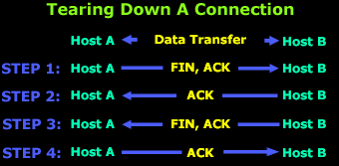
The above diagram represents an existing connection between Host A and B, where the two hosts are exchanging data. Once the data transfer is complete, Host A sends a packet with the FIN, ACK flags set (STEP 1).
With this packet, Host A is ACKnowledging the previous stream while at the same time initiating the TCP close procedure to kill this connection. At this point, Host A's application will stop receiving any data and will close the connection from this side.
In response to Host A's request to close the connection, Host B will send an ACKnowledgement (STEP 2) back, and also notify its application that the connection is no longer available. Once this is complete, the host (B) will send its own FIN, ACK flags (STEP 3) to close their part of the connection.
If you're wondering why this procedure is required, then you may need to recall that TCP is a Full Duplex connection, meaning that there are two directions of data flow. In our example this is the connection flow from Host A to Host B and vice versa. In addition, it requires both hosts to close the connection from their side, hence the reason behind the fact that both hosts must send a FIN flag and the other host must ACKnowledge it.
Lastly, at Step 4, Host A will acknowledge the request Host B sent at STEP 3 and the closedown procedure for both sides is now complete!

TCP Analysis - Section 5: Window Size, Checksum & Urgent Pointer

Introduction
Our fifth section contains some very interesting fields that are used by the TCP transport protocol. We see how TCP helps control how much data is transferred per segment, make sure there are no errors in the segment and, lastly, flag our data as urgent, to ensure it gets the priority it requires when leaving the sender and arriving at the recipient.
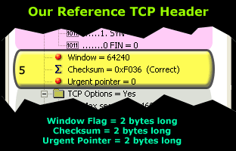 | The fifth section we are analyzing here occupies a total of 6 bytes in the TCP header. These values, like most of the fields in the protocol's header, remain constant in size, regardless of the amount of application data.  This means that while the values they contain will change, the total amount of space the field occupied will not.
The Window Flag
The Window size is considered to be one of the most important flags within the TCP header. This field is used by the receiver to indicate to the sender the amount of data that it is able to accept. Regardless of who the sender or receiver is, the field will always exist and be used.
You will notice that the largest portion of this page is dedicated to the Window size field. The reason behind this is because this field is of great importance. The Window size field is the key to efficient data transfers and flow control. It truly is amazing once you start to realize how important this flag is and how many functions it contains.
The Window size field uses 'bytes' as a metric. So in our example above, the number 64,240 is equal to 64,240 bytes, or 62.7 kb (64,240/1024).
The 62.7 Kbytes reflects the amount of data the receiver is able to accept, before transmitting to the sender (the server) a new Window value. When the amount of data transmitted is equal to the current Window value, the sender will expect a new Window value from the receiver, along with an acknowledgement for the Window just received.
The above process is required in order to maintain flawless data transmission and high efficiency. We should however note that the Window size field selected is not in any case just a random value, but one calculated using special formulas like the one in our example below:
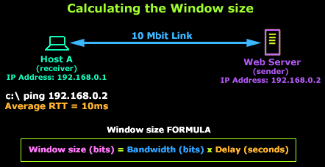
In this example, Host A is connected to a Web server via a 10 Mbit link. According to our formula, to calculate the best Window value we need the following information: Bandwidth and Delay. We are aware of the link's bandwidth: 10,000,000 bits (10 Mbits), and we can easily find out the delay by issuing a 'ping' from Host A to the Web server which gives us an average Round Trip Time response (RTT) of 10 milliseconds or 0.01 seconds.
We are then able to use this information to calculate the most efficient Window size (WS):
WS = 10,000,000 x 0.01 => WS = 100,000 bits or (100,000/8)/1024 = 12,5 Kbytes
For 10 Mbps bandwidth and a round-trip delay of 0.01 sec, this gives a window size of about 12 kb or nine 1460-byte segments:
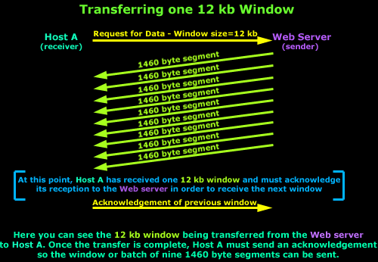
This should yield maximum throughput on a 10 Mbps LAN, even if the delay is as high as 10 ms because most LANs have round-trip delay of less than a few milliseconds. When bandwidth is lower, more delay can be tolerated for the same fixed window size, so a window size of 12 kb works well at lower speeds, too.
Windowing - A Form of Flow Control
Apart from the Windowing concept being a key factor for efficient data transmission, it is also a form of flow control, where a host (the receiver) is able to indicate to the other (the sender) how much data it can accept and then wait for further instructions.
The fact is that in almost all cases, the default value of 62 Kbytes is used as a Window size. In addition, even though a Window size of 62 Kbytes might have been selected by the receiver, the link is constantly monitored for packet losses and delays during the data transfer by both hosts, resulting in small increases or decreases of the original Window size in order to optimize the bandwidth utilization and data throughput.
This automatic self-correcting mechanism ensures that the two hosts will try to make use of the pipe linking them in the best possible way, but do keep in mind that this is not a guarantee that they will always succeed. This is generally the reason why a user is able to manually modify the Window size until the best value is found and this, as we explained, depends greatly on the link between the hosts and its delay.
In the case where the Window size falls to zero, the remote TCP can send no more data. It must wait until buffer space becomes available and it receives a packet announcing a non-zero Window size.
Lastly, for those who deal with Cisco routers, you might be interested to know that you are able to configure the Window size on Cisco routers running the Cisco IOS v9 and greater. Routers with versions 12.2(8)T and above support Window Scaling, a feature that's automatically enabled for Window sizes above 65,535, with a maximum value of 1,073,741,823 bytes!
Window Scaling will be dealt with in greater depth on the following page.
On the Server Side: Larger Window Size = More Memory
Most network administrators who have worked with very busy web servers would recall the massive amounts of memory they require. Since we now understand the concept of a 'Window size', we are able to quickly analyze how it affects busy web servers that have thousands of clients connecting to them and requesting data.
When a client connects to a web server, the server is required to reserve a small amount of memory (RAM) aside for the client's session. The amount of required memory is the same amount as the window size and, as we have seen, this value depends on the bandwidth and delay between the client and server.
To give you an idea how the window size affects the server's requirements in memory, let's take an example:
If you had a web server that served 10,000 clients on a local area network (LAN) running at 100 Mbits with a 0.1 second round trip delay and wanted maximum performance/efficiency for your file transfers, according to our formula, you would need to allocate a window of 1.25 MB for each client, or 12 Gigs of memory for all your clients! Assuming of course that all 10,000 clients are connected to your web server simultaneously.
To support large file transfers in both directions (server to client and vice versa), your server would need: [(100,000,000 x 0.1) 10,000 x 2] = over 24 Gigs of memory just for the socket buffers!
So you can see how important it is for clients not to use oversized window values! In fact, the current TCP standard requires that the receiver must be capable of accepting a full window's worth of data at all times. If the receiver over-subscribes its buffer space, it may have to drop an incoming packet. The sender will discover this packet loss and invoke TCP congestion control mechanisms even though the network is not congested.
It is clear that receivers should not over-subscribe buffer space (window size) if they wish to maintain high performance and avoid packet loss.
Checksum Flag
The TCP Checksum field was created to ensure that the data contained in the TCP segment reaches the correct destination and is error-free. For those network gurus who are wondering how TCP would ensure the segment arrives to the correct destination (IP Address), you will be happy to know that there is a little bit more information used than just the TCP header to calculate the checksum and, naturally, it would include a portion of the IP Header.
This 'extra' piece of information is called the pseudo-header and we will shortly analyze its contents but, for now, let's view a visual representation of the sections used to calculate the TCP checksum:
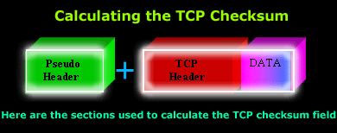
The above diagram shows you the pseudo header, followed by the TCP header and the data this segment contains. However, once again, be sure to remember that the pseudo header is included in the Checksum calculation to ensure the segment has arrived at the correct receiver.
Let's now take a look how the receiver is able to verify it is the right receiver for the segment it just received by analyzing the pseudo header.

The Pseudo Header
The pseudo header is a combination of 5 different fields, used during the calculation of the TCP checksum. It is important to note (and remember!) that the pseudo header is not transmitted to the receiver, but is simply involved in the checksum calculation.
Here are the 5 fields as they are defined by the TCP RFC:
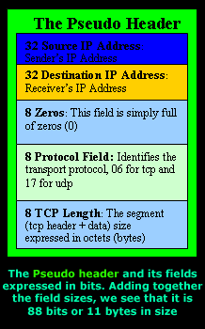 | When the segment arrives at its destination and is processed through the OSI layers, once the transport layer (Layer 4) is reached, the receiver will recreate the pseudo header in order to recalculate the TCP header checksum and compare the result with the value stored in the segment it has received.  If we assume the segment somehow managed to find its way to a wrong machine, when the pseudo header is recreated, the wrong IP Address will be inserted into the Destination IP Address field and the result will be an incorrect calculated checksum. Therefore, the receiver that wasn't supposed to receive the segment will drop it as it's obviously not meant to be there.  Now you know how the checksum field guarantees that the correct host will receive the packet, or that it will get there without any errors!

However, be sure to keep in mind that even though these mechanisms exist and work wonderfully in theory, when it comes to the practical part, there is a possibility that packets with errors might make their way through to the application!
It's quite amazing once you sit down and think for a minute that this process happens for every single packet that is sent and received between hosts that use TCP and UDP (UDP calculates the same way its checksum) as their transport protocol!
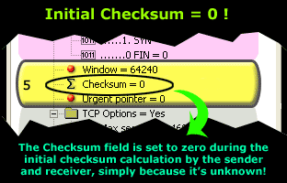 | Lastly, during the TCP header checksum calculation, the field is set to zero (0) as shown below. This action is performed only during the checksum calculation on either end because it is unknown at the time. Once the value is calculated, it is then inserted into the field, replacing the initial zero (0) value.  This is also illustrated in the screen shot to the left.
:
In summarizing the procedure followed when calculating the checksum, the following process occurs, from the sender all the way to the receiver:
The sender prepares the segment that is to be sent to the receiving end. The checksum is set to zero, in fact 4 zeros (hex) or 8 zeros (0000 0000) if you look at it in binary, because the checksum is an 8 bit field.
The checksum in then calculated using the pseudo header, TCP header and lastly the data to be attached to the specific segment. The result is then stored in the checksum field and the segment is sent!
The segment arrives at the receiver and is processed. When it reaches the 4th OSI layer where the TCP lives, the checksum field is set once again to zero. The receiver will then create its own pseudo header for the segment received by entering its own IP Address in the Destination IP Address field (as shown in the previous diagrams) and makes use of the TCP header and data to calculate the new checksum.
If all is successfully accomplished, the result should be identical with the one the checksum field segment had when it arrived. When this occurs, the packet is then further processed and the data is handed to the application awaiting it.
If, however, the checksum is different, then the packet should be discarded (dropped) and a notification will be sent to the receiver depending on how the TCP stack is implemented on the receiver's operating system.
The Urgent Pointer
In section 4, we analyzed the TCP Flag options and amongst them we found the Urgent Pointer flag. The urgent pointer flag in the TCP Flag allows us to mark a segment of data as 'urgent', while this urgent pointer field specifies where exactly the urgent data ends.
To help you understand this, take a look at the following diagram:
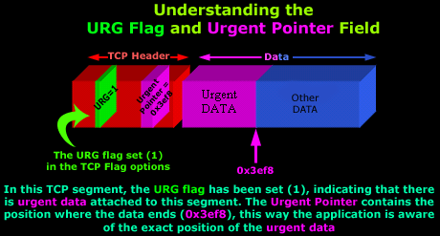
You may also be interested to know that the Urgent Pointer can also be used when attacking remote hosts. From the case studies we have analyzed, we see that certain applications, which supposedly guard your system from attack attempts, do not properly log attacks when the URG flag is set. One particular application happens to be the famous Black Ice Server v2.9, so beware!
As a final conclusion this section, if you find yourself capturing thousands of packets in order to view one with the URG bit set, don't be disappointed if you are unable to catch any such packets! We found it nearly impossible to get our workstation to generate such packets using telnet, http, ftp and other protocols. The best option and by far the easiest way would be to look for packet crafting programs that allow you to create packets with different flags and options set.

TCP Analysis - Section 6: TCP Options

Introduction
The TCP Options are located at the end of the TCP Header which is also why they are covered last. Thanks to the TCP Options field we have been able to enhance the TCP protocol by introducing new features or 'add-ons' as some people like to call them, defined by their respective RFC's.
As data communication continues to become more complex and less tolerable to errors and latency, it was clear that these new features had to be incorporated to the TCP transport to help overcome the problems created by the new links and speeds available.
To give you an example, Window Scaling, mentioned in the previous pages and elaborated here, is possible using the TCP Options field because the original Window field is only 16 bits long, allowing a maximum decimal number of 65,535. Clearly this is far too small when we want to express 'Window size' values using numbers in the range of thousands to a million e.g. 400,000 or 950,000.
Before we delve into any details, let's take a look at the TCP Options field:
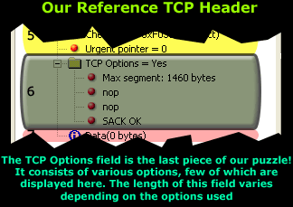 | As you can see, the TCP Options field is the sixth section of the TCP Header analysis.  Located at the end of the header and right before the Data section, it allows us to make use of the new enhancements recommended by the engineers who help design the protocols we use in data communications today.
TCP Options
Most of the TCP Options we will be analyzing are required to appear only during the initial SYN and SYN/ACK phase of the 3-way-handshake TCP performs to establish a virtual link before transferring any data. Other options, however, can be used at will, during the TCP session.
It is also important to note that the TCP Options may occupy space at the end of the TCP header and are a multiple of 8 bits in length. This means that if we use one TCP Option that is 4 bits in length, there must be another 4 bits of padding in order to comply with the TCP RFC. So the TCP Options length MUST be in multiples of 8 bits, that is 8, 16, 24, 32 e.t.c
Here's a brief view of the TCP Options we are going to analyze:
- Maximum Segment Size (MSS)
- Window Scaling
- Selective Acknowledgements (SACK)
- Timestamps
- Nop
Let's now take a look at the exciting options available and explain the purpose of each one.
Maximum Segment Size (MSS)
The Maximum Segment Size is used to define the maximum segment that will be used during a connection between two hosts. As such, you should only see this option used during the SYN and SYN/ACK phase of the 3-way-handshake. The MSS TCP Option occupies 4 bytes (32 bits) of length.
If you have previously come across the term "MTU" which stands for Maximum Transfer Unit, you will be pleased to know that the MSS helps define the MTU used on the network.
If your scratching your head because the MSS and MTU field doesn't make any sense to you, or it is not quite clear, don't worry, the following diagram will help you get the big picture:
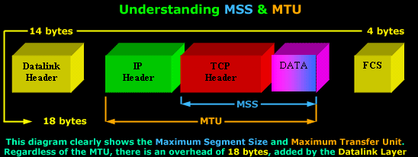
You can see the Maximum Segment Size consists of the TCP Header and Data, while the Maximum Transfer Unit includes the MSS plus the IP Header.
It would also benefit us to recognize the correct terminology that corresponds to each level of the OSI Model: The TCP Header and Data is called a Segment (Layer 4), while the IP Header and the Segment is called an IP Datagram (Layer 3).
Furthermore, regardless of the size the MTU will have, there is an additional 18 bytes overhead placed by the Datalink layer. This overhead includes the Source and Destination MAC Address, the Protocol type, followed by the Frame Check Sequence placed at the end of the frame.
This is also the reason why we can only have a maximum MTU of 1500 bytes. Since the maximum size of an Ethernet II frame is 1518 bytes, subtracting 18 bytes (Datalink overhead) leaves us with 1500 bytes to play with.
TCP usually computes the Maximum Segment Size (MSS) that results in IP Datagrams that match the network MTU. In practice, this means the MSS will have such a value that if we add the IP Header as well, the IP Datagram (IP Header+TCP Header+DATA) would be equal to the network MTU.
If the MSS option is omitted by one or both ends of the connection, then the value of 536 bytes will be used. The MSS value of 536 bytes is defined by RFC 1122 and is calculated by taking the default value of an IP Datagram, 576 bytes, minus the standard length of the IP and TCP Header (40 bytes), which gives us 536 bytes.
In general, it is very important to use the best possible MSS value for your network because your network performance could be extremely poor if this value is too large or too small. To help you understand why, lets look at a simple example:
If you wanted to transfer 1 byte of data through the network, you would need to create a datagram with 40 bytes of overhead, 20 for the IP Header and 20 for the TCP Header. This means that your using 1/41 of your available network bandwidth for data. The rest is nothing but overhead!
On the other hand, if the MSS is very large, your IP Datagrams will also be very large, meaning that they will most probably fail to fit into one packet should the MTU be too small. Therefore they will require to be fragmented, increasing the overhead by a factor of 2.
Window Scaling
We briefly mentioned Window Scaling in the previous section of the TCP analysis, though you will soon discover that this topic is quite broad and requires a great deal of attention.
After gaining a sound understanding of what the Window size flag is used for, Window Scaling is, in essence, an extention to the Window size flag. Because the largest possible value in the Window size flag is only 65,535 bytes (64 kb), it was clear that a larger field was required in order to increase the value to a whopping 1 Gig! Thus, Window Scaling was born.
The Window Scaling option can be a maximum of 30 bits in size, which includes the original 16 bit Window size field covered in the previous section. So that's 16 (original window field) + 14 (TCP Options 'Window Scaling') = 30 bits in total.
If you're wondering where on earth would someone use such an extremely large Window size, think again. Window Scaling was created for high-latency, high-bandwidth WAN links where a limited Window size can cause severe performance problems.
To consolidate all these technological terms and numbers, an example would prove to beneficial:
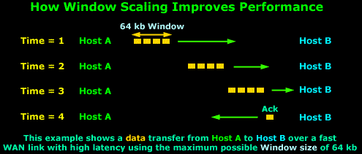
The above example assumes we are using the maximum Window size of 64 kbs and because the WAN link has very high latency, the packets take some time to arrive to their destination, that is, Host B. Due to the high latency, Host A has stopped transmitting data since there are 64 kbs of data sent and they have not yet been acknowledged.
When the Time = 4, Host B has received the data and sends the long awaited acknowledgement to Host A so it can continue to send data, but the acknowledgement will not arrive until somewhere around Time = 6.
So, from Time = 1 up until Time = 6, Host A is sitting and waiting. You can imagine how poor the performance of this transfer would be in this situation. If we were to transfer a 10 Mb file, it would take hours!
Let's now consider the same example, using Window Scaling:
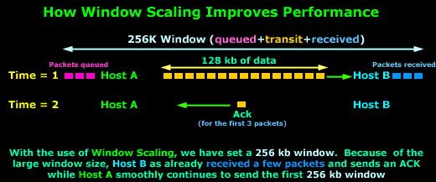
As you can see, with the use of Window Scaling, the window size has increased to 256 kb! Since the value is quite large, which translates to more data during transit, Host B has already received the first few packets, while Host A is still sending the first 256 kb window.
On Time = 2, Host B sends an Acknowledgement to Host A, which is still busy sending data. Host A will receive the Acknowledgement before it finishes the 256 kb window and will therefore continue sending data without pause since it will soon receive another Acknowledgement from Host B.
Clearly the difference that a large window size has made is evident, increasing the network performance and minimising the ideal time for the sending host.
The Window Scale option is defined in RFC 1072, which lets a system advertise 30-bit (16 from the original window + 14 from the TCP Options) Window size values, with a maximum buffer size of 1 GB. This option has been clarified and redefined in RFC 1323, which is the specification that all implementations employ today.
Lastly, for those who deal with Cisco routers, it may benefit you to know that you are also able to configure the Window size on Cisco routers running the Cisco IOS v9 and greater. Also, routers with versions 12.2(8)T and above support Window Scaling, which is automatically enabled for Window sizes above 65,535 bytes (64 kb), with a maximum value of 1,073,741,823 bytes (1 GByte)!
Selective Acknowledgments (SACK)
TCP has been designed to be a fairly robust protocol though, despite this, it still has several disadvantages, one of which concerns Acknowledgements, which also happens to be the reason Selective Acknowledgement were introduced with RFC 1072.
The problem with the good old plain Acknowledgements is that there are no mechanisms for a receiver to state "I'm still waiting for bytes 20 through 25, but have received bytes 30 through 35". And if your wondering whether this is possible, then the answer is 'yes' it is!
If segments arrive out of order and there is a hole in the receiver's queue, then using the 'classical' Acknowledgements supported by TCP, can only say "I've received everything up to byte 20". The sender then needs to recognize that something has gone wrong and continue sending from that point onwards (byte 20).
As you may have concluded, the above situation is totally unacceptable, so a more robust service had to be created, hence Selective Acknowledgments!
Firstly, when a virtual connection is established using the classic 3-way-handshake the hosts must send a "Selective Acknowledgments Permitted" in the TCP Options to indicate that they are able to use SACK's. From this point onwards, the SACK option is sent whenever a selective acknowledgment is required.
For example, if we have a Windows98 client that is waiting for byte 4,268, but the SACK option shows that the Windows98 client has also received bytes 7,080 through 8,486, it is obvious that it is missing bytes 4,268 through 7,079, so the server should only resend the missing 2,810 bytes, rather than restarting the entire transfer at byte number 4,268.
Lastly, we should note that the SACK field in the TCP Options uses two 16 bit fields, a total of 32 bits together. The reason there are two fields is because the receiver must be able to specify the range of bytes it has received, just like the example we used. In the case where Window Scaling is also used, these 2 x 16 bit fields can be expanded to two 24 or 32 bit fields.

Timestamps
Another aspect of TCP's flow-control and reliability services is the round-trip delivery times that a virtual circuit is experiencing. The round-trip delivery time will accurately determine how long TCP will wait before attempting to retransmit a segment that has not been acknowledged.
Because every network has unique latency characteristics, TCP has to understand these characteristics in order to set accurate acknowledgment timer threshold values. LANs typically have very low latency times, and as such TCP can use low values for the acknowledgment timers. If a segment is not acknowledged quickly, a sender can retransmit the questionable data quickly, thus minimizing any lost bandwidth and delay.
On the other hand, using a low threshold value on a WAN is sure to cause problems simply because the acknowledgment timers will expire before the data ever reaches the destination.
Therefore, in order for TCP to accurately set the timer threshold value for a virtual circuit, it has to measure the round-trip delivery times for various segments. Finally, it has to monitor additional segments throughout the connection's lifetime to keep up with the changes in the network. This is where the Timestamp option comes into the picture.
Similarly to the majority of the other TCP Options covered here, the Timestamp option must be sent during the 3-way-handshake in order to enable its use during any subsequent segments.
The Timestamp field consists of a Timestamp Echo and Timestamp Reply field, both of which the reply field is always set to zero by the sender and completed by the receiver after which it is sent back to the original sender. Both timestamp fields are 4 bytes long!
Nop
The nop TCP Option means "No Option" and is used to separate the different options used within the TCP Option field. The implementation of the nop field depends on the operating system used. For example, if options MSS and SACK are used, Windows XP will usually place two nop's between them, as was indicated in the first picture on this page.
Lastly, we should note that the nop option occupies 1 byte. In our example at the beggining of the page, it would occupy 2 bytes since it's used twice. You should also be aware that this field is usually checked by hackers when trying to determine the remote host's operating system.

TCP Analysis - Section 7: Data & Quick Summary

Introduction
Finally, the last page of our incredible TCP Analysis. As most of you would expect, this section is dedicated to the DATA, which is also the reason all the previous pages exist!
The Data
The following diagram may have been tiresome, however, it will be displayed one final time to note the data portion of the packet:
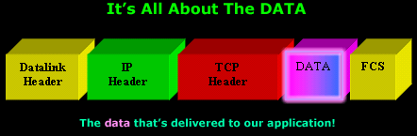
Your knowledge regarding the procedure followed when the above packet arrives to its destination is assumed. However, a summary is given below to refresh our understanding in order to avoid confusion.
When the above packet arrives at the receiver, a decapsulation process is required in order to remove each OSI layer's overhead and pass the Data portion to the application that's waiting for it. As such, when the packet is received in full by the network card, it is given to the 2nd OSI layer (Datalink) which, after performing a quick check on the packet for errors, it will strip the overhead associated with that layer, meaning the yellow blocks will be removed.
The remaining portion, that is, the IP header, TCP header and Data, now called an IP Datagram, will be passed to the 3rd OSI layer (Network) where another check will be performed and if found to be error free, the IP header will be stripped and the rest (now called a Segment) is passed to the 4th OSI layer.
The TCP protocol (4th OSI layer) will accept the segment and perform its own error check on the segment. Assuming it is found error free, the TCP header is stripped off and remaining data is given to the upper layers eventually arriving at the application waiting for it.

User Datagram Protocol - UDP
Some common protocols which use UDP are:
- DNS
- TFTP
- ARP
- RARP
- SNMP
. When people refer to "TCP/IP" remember that they are talking about a suite of protocols, and not just one (as most people think). TCP/IP is NOT one protocol. Please see the Protocols section for more information.
The User Datagram Protocol (UDP) is defined by IETF RFC768
UDP - User Datagram Protocol
The second protocol used at the Transport layer is UDP. Application developers can use UDP in place of TCP. UDP is the scaled-down economy model and is considered a thin protocol. Like a thin person in a car, a thin protocol doesn't take up a lot of room - or in this case, much bandwidth on a network.
UDP as mentioned dosen't offer all the bells and whistles of TCP, but it does a fabulous job of transporting information that doesn't require reliable delivery and it does so using far fewer network resources.
Unreliable Transport
UDP is considered to be an unreliable transport protocol. When UDP sends segments over a network, it just sends them and forgets about them. It doesn't follow through, check on them, or even allow for an acknowledgment of safe arrival, in other words.... complete abandonment! This does not mean that UDP is ineffective, only that it doesn't handle issues of reliability.
The picture below shows us the UDP header within a data packet. This is to show you the different fields a UDP header contains:
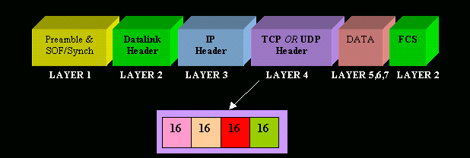
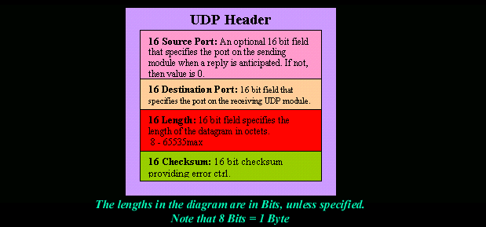
Connection-less Oriented
For those who read about TCP, you would know it is a connection oriented protocol, but UDP isn't. This is because UDP doesn't create a virtual circuit (establish a connection before data transfer), nor does it contact the destination before delivering information to it. No 3-way handshake or anything like that here!
Since UDP assumes that the application will use its own reliability method, it doesn't use any, which obviously makes things transfer faster.
Less Overhead
The very low overhead, compared to TCP, is a result of the lack of windowing or acknowledgments. This certainly speeds things up but you get an unreliable (in comparison to TCP) service.

Domain Name System (DNS)

Introduction
DNS is a very well known protocol. It is used for resolving host names and domain names to IP addresses. The fact is that when you type www.firewall.cx it is translated into an IP address via special queries that take place from your PC.

The DNS Protocol

Introduction
If you ever wondered where DNS came from, this is your chance to find out ! The quick summary on DNS's history will also help you understand why DNS servers are run mostly on Linux and Unix-type systems. We then get to see the layers of the OSI Model on which DNS works and, towards the end of the page, you will find out how the Domains (and DNS servers) are structured on the Internet to ensure uptime and effectiveness.
The History
DNS began in the early days when the Internet was only a small network created by the Department of Defence for research purposes. Host names (simple computer names) of computers were manually entered into a file (called HOSTS) which was located on a central server. Each site/computer that needed to resolve host names had to download this file. But as the number of hosts grew, so did the HOSTS file (Linux, Unix, Windows and NetWare still use such files) until it was far too large for computers to download and it was generating great amounts of traffic ! So they thought ... Stuff this .. let's find a better solution ... and in 1984 the Domain Name System was introduced.
The Protocol
The Domain Name System is a 'hierarchically distributed database', which is a fancy way of saying that its layers are arranged in a definite order and that its data is distributed across a wide range of machines (just like the roots of a tree branch out from the main root).
Most companies today have their own little DNS server to ensure the computers can find each other without problems. If you're using Windows 2000 and Active Directory, then you surely are using DNS for the name resolutions of your computers. Microsoft has created its own version of a "DNS" server, called a WINS server, which stands for Windows Internet Name Service, but this is old technology and uses protocols that are nowhere near as efficient as DNS, so it was natural for Microsoft to move away from WINS and towards DNS, after all, the whole Internet works on DNS :)
The DNS protocol works when your computer sends out a DNS query to a name server to resolve a domain. For example, you type "www.firewall.cx" in your web browser, this triggers a DNS request, which your computer sends to a DNS server in order to get the website's IP Address !

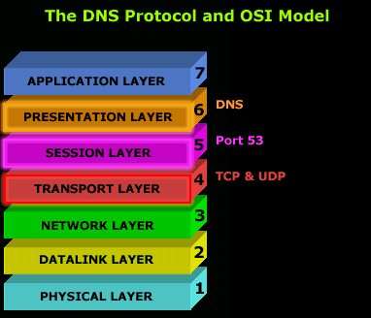 | The DNS protocol normally uses the UDP protocol as a means of transport because of its small overhead in comparison to TCP; the less overhead a protocol has, the faster it is !  In the case where there are constant errors and the computer trying to request a DNS resolution can't get an error free answer, or any answer at all, it will switch to TCP to ensure the data arrives without errors.
This process, though, depends on the operating system you're using. Some operating systems might not allow DNS to use the TCP protocol, thus limiting it to UDP only. It is rare that you will get so many errors that you can't resolve any hostname or domain name to an IP Address.
The DNS protocol utilizes Port 53 for its service. This means that a DNS server listens on Port 53 and expects any client wishing to use the service to use the same port. There are, however, cases where you might need to use a different port, something possible depending on the operating system and DNS server you are running.
In the following pages we'll be looking at the actual DNS packet format, where you are able to see exactly the contents of DNS query, so we won't analyze the packet structure here.
Next we'll take a close look at how the Internet domains and DNS servers are structured to make sure the model works flawlessly and efficiently !
The Internet Domain Name Server Hierarchy
This interesting section will help you understand how domain names on the Internet are structured and where DNS servers fit in to the picture. When you think about the millions of domain names registered today, you probably think that you have to be superhuman to manage such a structure of DNS servers !
Well that's not that case. The DNS structure has been designed in such a way that no DNS server needs to know about all possible domains, but only those immediately above and below it.
The picture below shows part of the Internet DNS hierarchical structure:
.......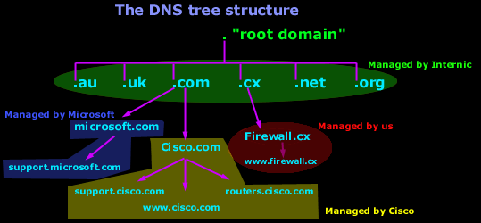
Let's explain how it works :
Internic controls the "root" domain, which includes all the top level domains. These are marked in a green oval for clarity. Within the green oval you have the ROOT DNS servers, which know all about the authoritative DNS servers for the domains immediately below them e.g. firewall.cx, cisco.com, microsoft.com etc. These ROOT DNS servers can tell you which DNS server takes care of firewall.cx, cisco.com, microsoft.com and the rest.
Each domain, including the ones we are talking about (cisco, firewall, microsoft), have what we call a "Primary DNS" and "Secondary DNS". The Primary DNS is the one that holds all the information about its domain. The Secondary acts as a backup in case the Primary DNS fails. The process in which a Primary DNS server sends its copy to the Secondary DNS server is called Zone Transfer and is covered in the DNS Database section.
Today there are hundreds of websites at which you are able to register your own domain and, once you've done that, you have the power to manage it yourself. In the example above, Cisco bought the "Cisco.com" domain and then created your resource records. Some examples of resource records for the Cisco domain in our example are: support , www and routers. These will be analyzed in depth on the next pages.
So here comes the million dollar question :)
How do you create subdomains and www's (known as resouce records) ?
The answer is pretty simple:
You use a special DNS administration interface (usually web based - provided by the guys with whom you registered your domain) that allows you to create, change and delete the subdomains, www's or whatever resource record you can come up with. When you're making changes to the DNS settings of your domain, you're actually changing the contents of specific files that are located on that server.
These changes then slowly propagate to the authoritative DNS servers, which are responsible for your domain area and then the whole Internet will contact these DNS servers when they need to access any section of your domain.
For example, if you need to resolve ftp.firewall.cx, your computer will locate and contact the DNS Server responsible for the .CX domains, which will let you know the DNS server that's in charge of the Firewall.cx domain. The DNS server of Firewall.cx in turn will let your computer know the IP Address of ftp.firewall.cx because it holds all the information for the firewall.cx domain.

Address Resolution Protocol

In computer networking, the Address Resolution Protocol (ARP) is the standard method for finding a host's hardware address when only its network layer address is known.
ARP is not an IP-only or Ethernet-only protocol; it can be used to resolve many different network-layer protocol addresses to hardware addresses, although, due to the overwhelming prevalence of IPv4 and Ethernet, ARP is primarily used to translate IP addresses to Ethernet MAC addresses. It is also used for IP over other LAN technologies, such as Token Ring, FDDI, or IEEE 802.11, and for IP over ATM.

Cases Using ARP
ARP is used in four cases of two hosts communicating:
- When two hosts are on the same network and one desires to send a packet to the other
- When two hosts are on different networks and must use a gateway/router to reach the other host
- When a router needs to forward a packet for one host through another router
- When a router needs to forward a packet from one host to the destination host on the same network
The first case is used when two hosts are on the same physical network (that is, they can directly communicate without going through a router). The last three cases are the most used over the Internet as two computers on the internet are typically separated by more than 3 hops.
In the first case, you would have two hosts, A and B, on the same LAN segment. If, for example, Host A wants to send an IPv4 packet to Host B, Host A must already have an IPv4 (network layer) address for Host B. However, in order to be able to send the packet on the LAN to Host B, Host A must also have a data link layer address, i.e. a MAC address, for Host B. If it doesn't already know that MAC address, it would send an ARP request to ask for that MAC address, in hope of getting a reply from Host B, or another host on the network, returning the required MAC address.
In the second case, for the same example, hosts A and B would be on different network segments, but there would be a router, on the same LAN segment as Host A, which is either on the same network segment as Host B, or on the same network segment as another router that is on the same network segment as Host B, or on the same network segment as another router that is on the same network segment as yet another router that is on the same segment as Host B, and so on. Host A would send the IPv4 packet not to Host B, but to the first of those routers; it would look up Host B in its routing table to determine the IPv4 address of the appropriate router. It would then, if it doesn't already know the MAC address of that router, use ARP to determine that MAC address.
The third case is similar to the second case; the router would look up Host B in its routing table to determine the IPv4 address of the next router to which it should send the packet and, if it doesn't already know the MAC address for the router, use ARP to determine that MAC address. The fourth case is similar to the first case; the router has determined that Host B is on the same LAN segment, and, if it doesn't already know Host B's MAC address, will use ARP to determine that MAC address.
ARP is defined in RFC 826. It is a current Internet Standard, STD 37.

Variants of the protocol
ARP has also been adapted to resolve other kinds of Layer 2 addresses; for example, ATMARP is used to resolve ATM NSAP addresses in the Classical IP over ATM protocol.

ARP mediation
ARP mediation refers to the process of resolving Layer 2 addresses when different resolution protocols are used on either circuit, e.g. ATM on one end and Ethernet on the other.

Inverse ARP
The Inverse Address Resolution Protocol, also known as Inverse ARP or InARP, is a protocol used for obtaining Layer 3 addresses (e.g. IP addresses) of other stations from Layer 2 addresses (e.g. the DLCI in Frame Relay networks). It is primarily used in Frame Relay and ATM networks, where Layer 2 addresses of virtual circuits are sometimes obtained from Layer 2 signaling, and the corresponding Layer 3 addresses must be available before these virtual circuits can be used.
ARP translates Layer 3 addresses to Layer 2 addresses, therefore InARP can be viewed as its inverse. In addition, InARP is actually implemented as an extension to ARP. The packet formats are the same; only the operation code and the filled fields differ.
Reverse ARP (RARP), like InARP, also translates Layer 2 addresses to Layer 3 addresses. However, RARP is used to obtain the Layer 3 address of the requesting station itself, while in InARP the requesting station already knows its own Layer 2 and Layer 3 addresses, and it is querying the Layer 3 address of another station. RARP has since been abandoned in favor of BOOTP which was subsequently replaced by DHCP.

Packet structure
The following is the packet structure used for ARP requests and replies. On Ethernet networks, these packets use an EtherType of 0x0806, and are sent to the broadcast MAC address of FF:FF:FF:FF:FF:FF. Note that the packet structure shown in the table has SHA, SPA, THA, & TPA as 32-bit words but this is just for convenience — their actual lengths are determined by the hardware & protocol length fields.

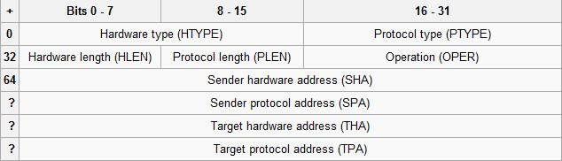

Hardware type (HTYPE)
Each data link layer protocol is assigned a number used in this field. For example, Ethernet is 1.
Protocol type (PTYPE)
Each protocol is assigned a number used in this field. For example, IPv4 is 0x0800.
Hardware length (HLEN)
Length in bytes of a hardware address. Ethernet addresses are 6 bytes long.
Protocol length (PLEN)
Length in bytes of a logical address. IPv4 address are 4 bytes long.
Operation
Specifies the operation the sender is performing: 1 for request, and 2 for reply.
Sender hardware address (SHA)
Hardware address of the sender.
Sender protocol address (SPA)
Protocol address of the sender.
Target hardware address (THA)
Hardware address of the intended receiver. This field is ignored in requests.
Target protocol address (TPA)
Protocol address of the intended receiver.

Example request
If a host with IPv4 address of 10.10.10.123 (0A.0A.0A.7B in hexadecimal notation) and MAC address of 00:09:58:D8:11:22 wants to send a packet to another host at 10.10.10.140 (0A.0A.0A.8C in hexadecimal notation) but it does not know the MAC address, then it must send an ARP request to discover the address. The packet shown shows what would be broadcast over the local network.
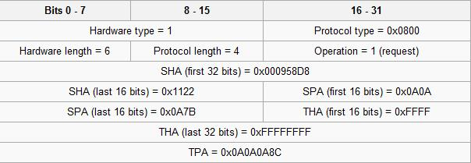

Example reply
Given the scenario laid out in the request section, if the host 10.10.10.140 is running and available, then it would receive the ARP request and send a reply packet as shown below. (This reply assumes that the host 10.10.10.140 has a MAC address of 00:09:58:D8:33:AA.) Note that the sender and target address blocks have been swapped (the sender of the reply is the target of the request; the target of the reply is the sender of the request). Furthermore, the host 10.10.10.140 has filled in its MAC address in the sender hardware address.
Any hosts on the same network as these two hosts would also see the request (since it is a broadcast) so they are able to cache information about the source of the request. The ARP reply (if any) is directed only to the originator of the request so information in the ARP reply is not available to other hosts on the same network.
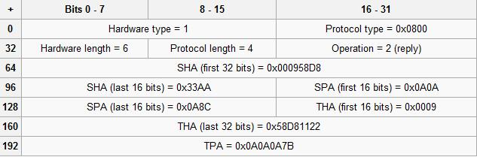

ARP Announcements(Gratuitous ARP)

An ARP announcement (also known as "Gratuitous ARP") is a packet (usually an ARP Request ) containing a valid SHA and SPA for the host which sent it, with TPA equal to SPA. Such a request is not intended to solicit a reply, but merely updates the ARP caches of other hosts which receive the packet.
This is commonly done by many operating systems on startup, and helps to resolve problems which would otherwise occur if, for example, a network card had recently been changed (changing the IP-address-to-MAC-address mapping) and other hosts still had the old mapping in their ARP caches.
ARP announcements are also used to defend link-local IP addresses in the RFC 3927 (Zeroconf) protocol, and for IP address takeover within high-availability clusters.

ARP Probe
This term is used in the "IPv4 Address Conflict Detection" draft specification. Before beginning to use an IPv4 address (whether received from manual configuration, DHCP, or some other means), a host implementing this specification MUST test to see if the address is already in use, by broadcasting ARP probe packets. An ARP Request constructed with an all-zero 'sender IP address' is referred to as an "ARP Probe".

File Transfer Protocol - FTP

Introduction
File transfer is among the most frequently used TCP/IP applications and it accounts for a lot of the network traffic on the Internet. Various standard file transfer protocols existed even before the Internet was available to everyone and it was these early versions of the file transfer software that helped create today's standard known as the File Transfer Protocol (FTP). Most recent specifications of the protocol are listed in RFC 959.
The Protocol
FTP uses TCP as a transport protocol. This means that FTP inherits TCP's robustness and is very reliable for transferring files. Chances are if you download files, you've probably used ftp a few hundred times without realising it ! And if you have a huge warez collection, then make that a couple of thousand times :)
The picture below shows where FTP stands in contrast to the OSI model. As I have noted in other sections, it's important to understand the concept of the OSI model, because it will greatly help you understand all this too :)
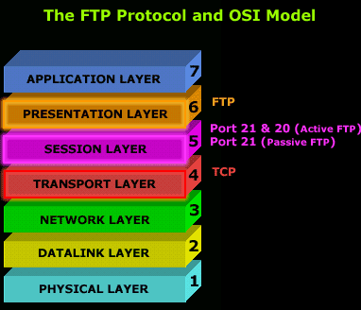
Now, we mentioned that FTP uses TCP as a transport, but we didn't say which ports it uses! Port numbers 21 and 20 are used for FTP. Port 21 is used to establish the connection between the 2 computers (or hosts) and port 20 to transfer data (via the Data channel).
But there are some instances where port 21 is used for both, establishing a connection and data transfer and I will analyze them shortly.

The best thing you can do to "see" it yourself is to grab a packet sniffer which you will conveniently find in our download section and try to capture a few packets while you're ftp'ing to a site.
Both Ports - 20 and 21 - Active FTP Mode
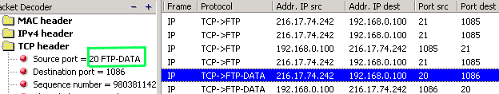

Only Port 21 - Passive FTP Mode
Now, in the next picture I ftp'ed into my NetWare server here at home and guess what .... Only Port 21 was used ! Here is the screen shot:
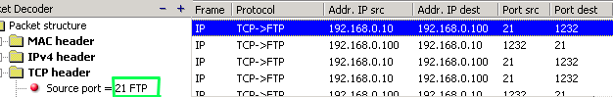
FTP has two separate modes of operation: Active and Passive. You will use either one depending on whether your PC is behind a firewall.
Active Mode FTP
Active mode is usually used when there isn't any firewall between you and the FTP server. In such cases you have a direct connection to the Internet. When you (the client) try to establish a connection to a FTP server, your workstation includes a second port number (using the PORT command) that is used when data is to be exchanged, this is known as the Data Channel.
The FTP server then starts the exchange of data from its own port 20 to whatever port was designated by your workstation (in the screen shot, my workstation used port 1086), and because the server initiated the communication, it's not controlled by the workstation client. This can also potentially allow uninvited data to arrive to your computer from anywhere posing as a normal FTP transfer. This is one of the reasons Passive FTP is more secure.

Passive Mode FTP
Using normal or passive FTP, a client begins a session by sending a request to communicate through TCP port 21, the port that is conventionally assigned for this use at the FTP server. This communication is known as the Control Channel connection.
At this point, a PASV command is sent instead of a PORT command. Instead of specifying a port that the server can send to, the PASV command asks the server to specify a port it wishes to use for the Data Channel connection. The server replies on the Control Channel with the port number which the client then uses to initiate an exchange on the Data Channel. The server will thus always be responding to client-initiated requests on the Data Channel and the firewall can correlate these.
It's simple to configure your client FTP program to use either Active or Passive FTP. For example, in Cute FTP, you can set your program to use Passive FTP by going to FTP--> Settings --> Options and then selecting the "Firewall" tab :
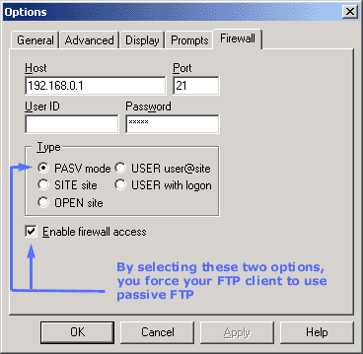
If you remove the above options, then your workstation will be using (if possible) Active FTP mode, and I say "if possible" cause if your already behind a firewall, there is probably no way you will be using Active FTP, so the program will automatically change to Passive FTP mode.
So let's have a look at the process of a computer establishing an FTP connection with a server: .
........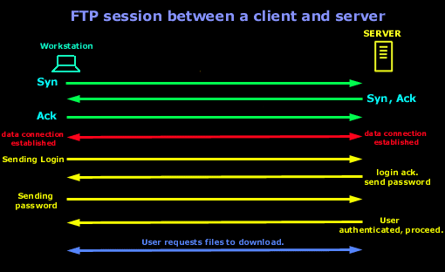..........
The above is assuming a direct connection to the FTP server. For simplicity reasons, we are looking at the way the FTP connection is created and not worring if it's a Passive or Active FTP connection. Since FTP is using TCP as a transport, you would expect to see the 3-way handshake. Once that is completed and there is data connection established, the client will send its login name and then password. After the authentication sequence is finished and the user is authenticated to the Server, it's allowed access and is ready to leach the site dry :)
Finally, below are the most commonly used FTP commands:
ABOR: abort previous FTP command
LIST and NLST: list file and directories
DELE: delete a file
RMD: remove a directory
MKD: create a directory
PWD: print current working directory ( show you which dir. your at)
PASS: send password USER: send username
PORT: request open port number on specific IP address/port number
QUIT: log off from server
RETR: retrieve file STOR: send or put file
SYST: identity system type TYPE: specify type (A for ASCII, I for binary)

The Internet Control Message Protocol

Introduction
The Internet Control Message Protocol, or ICMP as we will be calling it, is a very popular protocol and actually part of an Internet Protocol (IP) implementation. Because IP wasn't designed to be absolutely reliable, ICMP came into the scene to provide feedback on problems which existed in the communication environment.
If I said the word 'Ping' most people who work with networks would recognize that a 'ping' is part of ICMP and in case you didn't know that, now you do :)
ICMP is one of the most useful protocols provided to troubleshoot network problems like DNS resolutions, routing, connectivity and a lot more. Personally, I use ICMP a lot, but you need to keep its limits in mind beause you might end up spending half a day trying to figure out why you're not getting a 'ping reply' ('echo reply' is the correct term) from, for example, www.firewall.cx when, in fact, the site's webserver is configured NOT to reply to 'pings' for security reasons !
The Protocol
ICMP is defined in RFC (Request For Comments) 792. Looking at its position in the OSI model we can see that it's sitting in the Network layer (layer 3) alongside IP. There are no ports used with ICMP, this is because of where the protocol sits in the OSI model. Ports are only used for protocols which work at the Session layer and above:
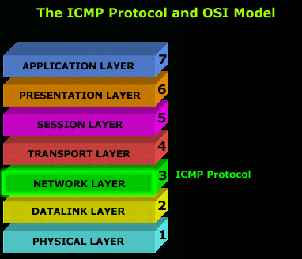 | The ICMP protocol uses different 'messages' to identify the purpose of an ICMP packet, for example, an 'echo' (ping) is one type of ICMP message.
We will start with a visual example of where the ICMP header and information are put in a packet, to help you understand better what we are dealing with :)
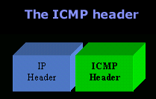
The structure is pretty simple, not a lot involved, but the contents of the ICMP header will change depending on the message it contains. For example, the header information for an 'echo' (ping) message (this is the correct term) is different to that of a 'destination unreachable' message, also a function of ICMP.
The table below shows all the ICMP messages the protocol supports.
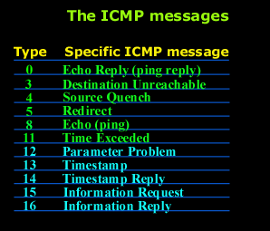

ICMP - Echo / Echo Reply (Ping) Message

Introduction
As mentioned in the previous page, an Echo is simply what most people call a 'ping'. The Echo Reply is the 'ping reply'. ICMP Echos are used mostly for troubleshooting. When there are 2 hosts which have communication problems, a few simple ICMP Echo requests will show if the 2 hosts have their TCP/IP stacks configured correctly and if there are any problems with the routes packets are taking in order to get to the other side.
The 'ping' command is very well known, but the results of it are very often misunderstood and for that reason I have chosen to explain all those other parameters next to the ping reply, but we will have a look at that later on.
Let's have a look at what an ICMP-Echo or Echo Reply packet looks like:
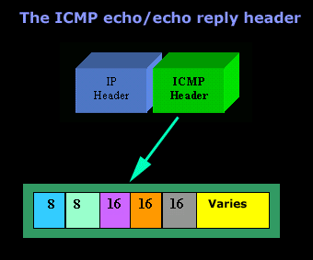
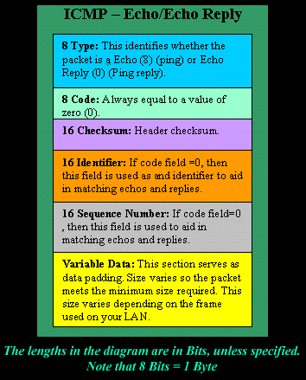
If the above packet was an ICMP Echo (ping), then the Type field takes a value of 8. If it's an ICMP Echo Reply (ping reply) then it would take a value of 1.
The picture below is a screen shot I took when doing a simple ping from my workstation:
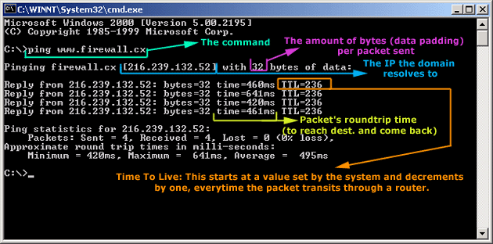
Okay, now looking at the screen shot above, you can see I 'pinged' www.firewall.cx. The first thing my workstation did was to resolve that URL to an IP address. This was done using DNS. Once the DNS server returned the IP address of www.firewall.cx, the workstation generated an ICMP packet with the Type field set to 8.
Here is the proof:
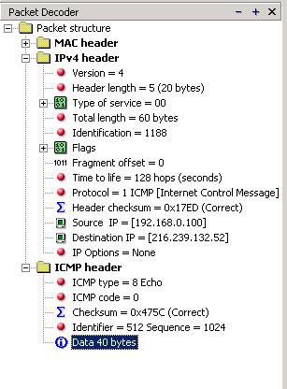
The picture above is a screenshot from my packet sniffer the same time this experement was taking place. The packet displayed is one of the 4 packets which were sent from my workstation to the webserver of firewall.cx
Notice the ICMP type = 8 Echo field right under the ICMP Header section. This clearly shows that this packet is being sent from the workstation and not received. If it was received, it would have been an 'Echo Reply' and have a value of 1.
The next weird thing, if anyone noticed, is the data field. Look at the screen shot from command prompt above and notice the value there and the value the packet sniffer is showing on the left. One says 32 Bytes, and the other 40 Bytes !
The reason for this is that the packet sniffer is taking into account the ICMP header files (ICMP type, code, checksum and identifier), and I'll prove it to you right now.
Look at the top of this page where we analyzed the ICMP headers (the 3d picture), you will notice that the lengths (in Bits) of the various fields are as follows: 8, 8, 16, 16, 16. These add up to a total of 64 Bits. Now 8 Bits = 1 Byte, therefore 64 Bits = 8 Bytes. Take the 32 Bytes of data the workstation's command prompt is showing and add 8 Bytes .... and you have 40 Bytes in total.

ICMP - Destination Unreachable Message

Introduction
This ICMP message is quite interesting, because it doesn't actually contain one message, but six! This means that the ICMP Destination unreachable futher breaks down into 6 different messages.
We will be looking at them all and analyzing a few of them to help you get the idea.
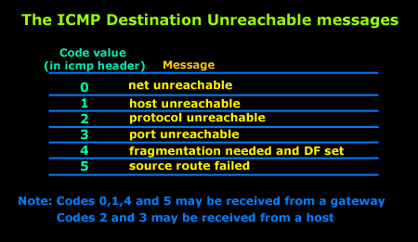
To make sure you don't get confused, keep one thing in mind: The ICMP Destination unreachable is a generic ICMP message, the different code values or messages which are part of it are there to clarify the type of "Destination unreachable" message was received. It goes something like this: ICMP Destination <Code value or message> unreachable.
The ICMP - Destination net unreachable message is one which a user would usually get from the gateway when it doesn't know how to get to a particular network.
The ICMP - Destination host unreachable message is one which a user would usually get from the remote gateway when the destination host is unreachable.
If, in the destination host, the IP module cannot deliver the packet because the indicated protocol module or process port is not active, the destination host may send an ICMP destination protocol / port unreachable message to the source host.
In another case, when a packet received must be fragmented to be forwarded by a gateway but the "Don't Fragment" flag (DF) is on, the gateway must discard the packet and send an ICMP destination fragmentation needed and DF set unreachable message to the source host.
These ICMP messages are most useful when trying to troubleshoot a network. You can check to see if all routers and gateways are configured properly and have their routing tables updated and synchronised.
Let's look at the packet structure of an ICMP destination unreachable packet:
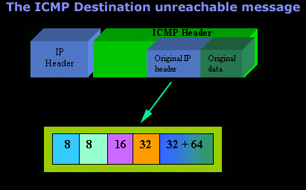
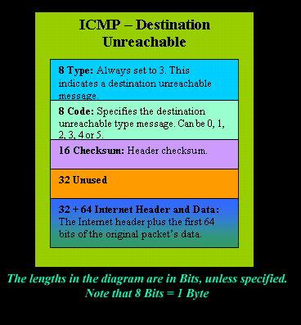
Please read on as the following example will help you understand all the above.

The Analysis
When you open a DOS command prompt and type "ping 200.200.200.200", assuming that your workstation is NOT part of that network, then it would forward the ICMP Echo request to the gateway that's configured in your TCP/IP properties. At that point, the gateway should be able to figure out where to forward the ICMP Echo request.
The gateway usually has a "default route" entry, this entry is used when the gateway doesn't know where the network is. Now, if the gateway has no "default route" you would get an "ICMP Destination net unreachable" message when you try to get to a network which the gateway doesn't know about. When you're connected to the Internet via a modem, then your default gateway is the modem.
In order for me to demonstrate this, I set up my network in a way that should make it easy for you to see how everything works. I have provided a lot of pictures hoping to make it as easy as possible to understand.
I will analyze why and how you get an "ICMP - Destination net unreachable" message.
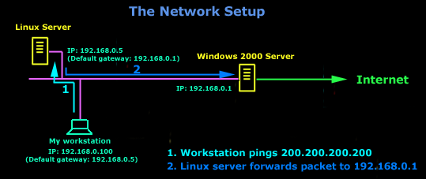
In the example above, I've setup my workstation to use the Linux server as a default gateway, which has an IP of 192.168.0.5. The Linux server also has a default gateway entry and this is IP: 192.168.0.1 (the Windows 2000 Server).
When my workstation attempts to ping (send an ICMP Echo request) to IP 200.200.200.200, it realizes it's on a different network, so it sends it to the Linux server, which in turn forwards it to its default gateway (the Win2k server) so it can then be forwarded to the Internet and eventually I should get a ping reply (ICMP Echo reply) if the host exists and has no firewall blocking ICMP echo requests.
Here is the packet which I captured:
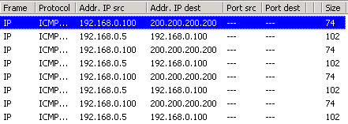
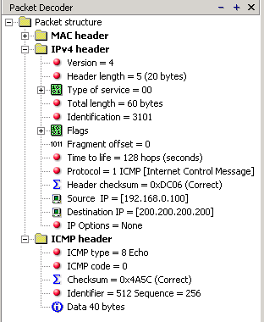
When looking at the decoded section (picture above) you can see in the ICMP header section that the ICMP Type is equal to 8, so this confirms that it's an ICMP Echo (ping). As mentioned earlier, we would expect to receive an ICMP echo reply.
Check out though what happens when I remove the default gateway entry from the Linux server:
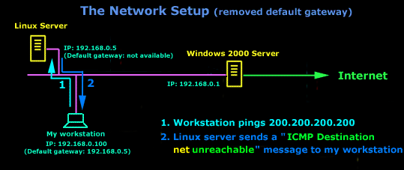
Now what I did was to remove the default gateway entry from the Linux server. So when it gets a packet from my workstation, it wouldn't know what to do with it. This is how you get the gateway to generate an "ICMP Destination net unreachable" message and send it back to the source host (my workstation).
Here is a screen shot from the command prompt:
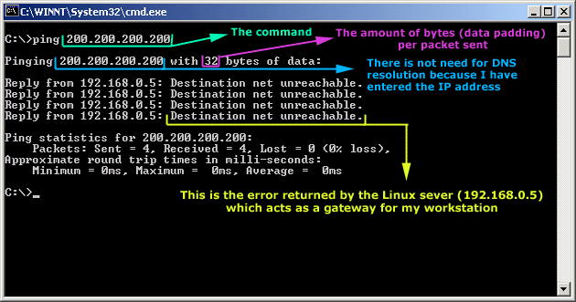
As you can see, the Linux server has returned an "ICMP Destination net unreachable". This is one of the six possible 'ICMP Destination Unreachable' messages as listed at the beginning of this page. The Linux server doesn't know what to do with the packet since it has no way of getting to that 200.200.200.0 network, so it sends the "ICMP Destination net unreachable" message to my workstation, notifiying it that it doesnt know how to get to that network.
Let's now take a look what the packet sniffer caught :
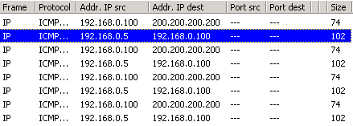
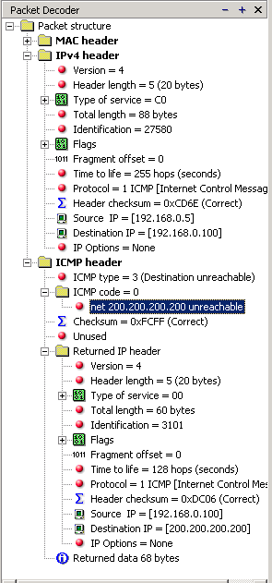 | The decoder on the left shows that the Linux server (192.168.0.5) sent back to my workstation (192.168.0.100) an ICMP Destination unreachable message (look at the ICMP type field, right under the ICMP header) but if you also check out the ICMP Code (highlighted field), it's equal to 0, which means "net unreachable". Scrolling right at the top of this page, the first table clearly shows that when the code field has a value of 0, this is indeed a "net unreachable" message.  It is also worth noticing the "Returned IP header" which exists within the ICMP header. This is the IP header of the packet my workstation sent to the Linux server when it attempted to ping 200.200.200.200, and following that is 64 bits (8 bytes) of the original data.

ICMP - Source Quench Message

Introduction
The ICMP - Source quench message is one that can be generated by either a gateway or host. You won't see any such message pop up on your workstation screen unless you're working on a gateway which will output to the screen all ICMP messages it gets. In short, an ICMP - Source quench is generated by a gateway or the destination host and tells the sending end to ease up because it cannot keep up with the speed at which it's receiving the data.
Analysis
Now let's get a bit more technical: A gateway may discard internet datagrams (or packets) if it does not have the buffer space needed to queue the datagrams for output to the next network on the route to the destination network. If a gateway discards a datagram, it may send an ICMP - Source quench message to the internet source host of the datagram.
Let's have a look at the packet structure of the ICMP - Source quench message:
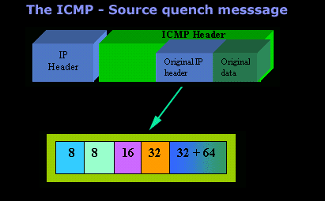
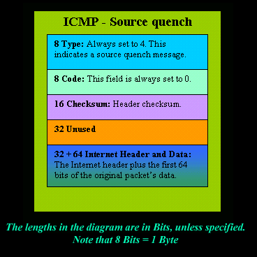
A destination host may also send an ICMP - Source quench message if datagrams arrive too fast to be processed. The ICMP - Source quench message is a request to the host to cut back the rate at which it is sending traffic to the internet destination. The gateway may send an ICMP - Source quench for every message that it discards. On receipt of an ICMP - Source quench message, the source host should cut back the rate at which it is sending traffic to the specified destination until it no longer receives ICMP - Source quench messages from the gateway. The source host can then gradually increase the rate at which it sends traffic to the destination until it again receives ICMP - Source quench messages.
The gateway or host may also send the ICMP - Source quench message when it approaches its capacity limit rather than waiting until the capacity is exceeded. This means that the data datagram which triggered the ICMP - Source quench message may be delivered.

ICMP - Redirect Message

Introduction
The ICMP - Redirect message is always sent from a gateway to the host and the example below will illustrate when this is used.
Putting it simply (before we have a look at the example) the ICMP - Redirect message occurs when a host sends a datagram (or packet) to its gateway (destination of this datagram is a different network), which in turn forwards the same datagram to the next gateway (next hop) and this second gateway is on the same network as the host. The second gateway will generate this ICMP message and send it to the host from which the datagram originated.
There are 4 different ICMP - Redirect message types and these are:
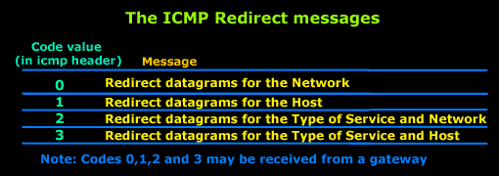
The format of this ICMP message is as follows: ICMP - Redirect (0, 1, 2, 3 or 4) message.

Analysis
Let's have a look at the structure of an ICMP - Redirect message:
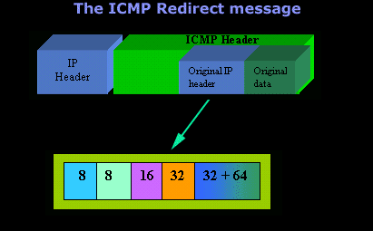
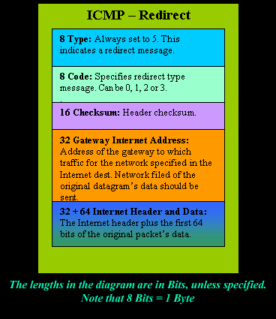

ICMP - Time Exceeded Message

Introduction
The ICMP - Time exceeded message is one which is usually created by gateways or routers. In order to fully understand this ICMP message, you must be familiar with the IP header within a packet. If you like you can go to the Download - Documents section and grab a copy of the TCP/IP in a Ethernet II Frame file which breaks down the IP header nicely.
When looking at an IP header, you will see the TTL and Fragment Flag fields which play a big part in how this ICMP message works. Please make sure you check them out before attempting to continue !
The ICMP - Time exceeded message is generated when the gateway processing the datagram (or packet, depending on how you look at it) finds the Time To Live field (this field is in the IP header of all packets) is equal to zero and therefore must be discarded. The same gateway may also notify the source host via the time exceeded message.
The term 'fragment' means to 'cut to pieces'. When the data is too large to fit into one packet, it is cut into smaller pieces and sent to the destination. On the other end, the destination host will receive the fragmented pieces and put them back together to create the original large data packet which was fragmented at the source.
Analysis
Let's have a look at the structure of an ICMP - Time exceeded message:
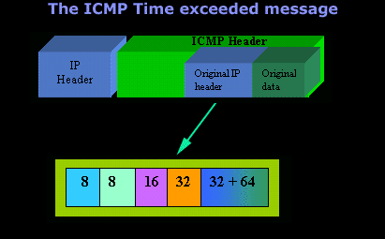
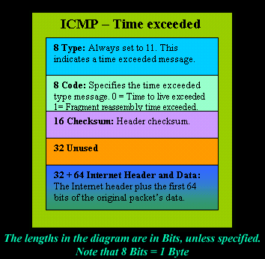
If a host reassembling a fragmented datagram (or packet) cannot complete the reassembly due to missing fragments within its time limit it discards the datagram and it may send an ICMP - time exceeded message.
If fragment zero is not available then no ICMP - time exceeded message is needed to be sent at all. Code 0 may be received from a gateway and Code 1 from a host.
So, summing it up, an ICMP - Time exceeded message can be generated because the Time to live field in the IP header has reached a value of zero (0) or because a host reassembling a fragmented datagram cannot complete the reassembly within its time limit because there are missing fragments (Fragment reassembly time exceeded the allocated time).

REFRENCES

- www.firewall.cx
- www.wikipedia.org
- www.about.com
- www.ethreal.com
- www.netresearch.ics.uci.edu/kfujii/jpcap/doc/index.html
- www.google.com
- www.java.sun.com

